Analysis Me

**Fall**

2015

**Project 2 Service-Oriented Scientific Collaboration Social Network**

**--Zetwork**

Technical Report

Service Oriented Computing (18-655)

**Instructor: Jia Zhang**

**Team Member: Shuting Xi**

**Pan Li**

**Nianzu Tang**

**Shuoyao Ma**

# Table of Contents

1. Introduction……………………………………………………………………………………………………………..3
2. Motivation…………………………………………………………………………………………………………….…3
3. Related Work……………………………………………………………………………………………….……….….4
4. System Design……………………………………………………………………………………………...…….……5
5. System Implementation…………………………………………………………………………………….……13
6. Experiments and Analysis………………………………………………………………………………….……19
7. Conclusions and Future Work…………………………………………………………………………………34
8. Contribution of Each Team Member……………………………………………………..…...……...….35
9. Tutorial……………………………………………………………………………………………………………..……35
10. Appendix…………………………………………………………………………………………………………..……51
11. **Introduction**

In this project, we have been introduced to a fully functional and interesting social network project. We have put in our own design in this project and achieved extra features for the web site to perfectify the user experience of our product.

In recent years, people start to spend a lot of time on social networks. The power of social media has stronger and stronger influence and impact in modern society. In social networks, people can "friend" each other or post status of individual user. All these interesting interactions between individual users makes the social network a fun place for friends and family to hang out. In another perspective, more and more business and enterprise are getting involved in the social network area, where the social network itself are used as efficiency tool for the enterprise or business.

In the background of this project, we are inspired by the idea of "Twitter within a company", to create a social network website that can be adopted in the research area, where the main users for this website are science researchers and any relative role people play in the science industry. They can share their personal profile of information in his personal main page for other users to view. If a certain user is interested in the research interest listed in the user profile, he/she can follow that researcher. Whenever a user is followed, his/her new post, which is a way for that user to share information within the social network, will be displayed on their followers page. In this sense, the social network we developed for this project is kind of like a "Twitter" but more focused on the science research theme. More content will be thoroughly discussed in the rest of the report.

This report is constructed as follows:

First, we are going to tell you the motivation behind our project. Then we are going to talk about the related work we have received to develop our project. After that, we will show you the system design of our project, including front end and back end. Follow that, the detailed system implementation will be listed. Then we are going to show you the experiments we have done for our project, which also comes the analysis for them. Then, the conclusion will be drawn for our project and future work that could be done will be discussed. Last but not the lease, a detailed tutorial will be given to walk you through our project.

1. **Motivation**

In this section, we are going to talk about the motivation behind this project, regarding why we are developing this project and where we are coming from.

The first thing you need to know about modern society is that we are in an information explosion time in history. We are surrounded by information we might or we might care for. One of the major success stories about social network component is Microblogging. Microblogging is a broadcast medium that exists in the form of blogging. A microblog differs from a traditional blog in that its content is typically smaller in both actual and aggregated file size. Microblogs allow users to exchange small elements of content such as short sentences and image or video media, which may be the major reason for their popularity. These small messages are sometimes called microposts.

In the industry of scientific research, we think microblogging has its own natural advantages, for instance, science researchers are always devoted to their work and sometimes they take down of little notes of their discovery here and there, in a hurry with little notes, but later found them missing. What if we can create a social network website, so that the researcher can take down the notes and record it in his/her own repository. What is even better is that if he/she decided to share this piece of information or discovery, he/she can change the status of little piece of information from private to public, so that the followers of this user can view this note, which is the micropost in our case.

Strongly motivated by this interesting and inspiring idea, we developed a social network website mainly for science researchers, where they can share private or public posts, follow or unfollow fellow researchers, view posts of his/her own or of others, edit personal information to connect with fellow researchers with common research interest. We call this comprehensive social network the "ZETWORK"! In our vision, ZETWORK can be a popular hit product in the science research industry. It will win peoples' hearts with its delicate UI design and professional functionality and services provided for users. People in the industry will be gushing about this website and all signed up for our service.

1. **Related Work**

Our project is based on the apache project. We added our own design of the project onto the existed climate project provided to us. In general, in order to add new functions, we managed to add code to both the frontend and backend, which will be discussed as follows:

**Apache_CMDA_Frontend**

Under app/views: we wrote several web pages files in scala, referencing the example from the climateServices.scala.html file. We developed structure to retrieve data: for our social network service from backend.

Under models.metadata: we wrote our models to implemet for this project: e.g., Post.java, Follower.java, Comment.java, which will call backend APIs: for example, APICall.callAPI(GET_CLIMATESERVICES_ALL). Note that the model, User.java, is based on the original project, which has already been thoroughly written and fully functioned in multiple aspects of the User model's needs.

For controllers, we have writen a few controllers corresponding to the models in our project, e.g., PostController.java - Result postServices(postServiceForm).

In addition, some utility files worth mentioning are APICall.java under Util package and Constants.java also under Util package where we define final static constants such as backend port (e.g., NEW_API_URL = 9033).

**Apache_CMDA_Backend**

Under models: we have written the models code, e.g., Post.java, Follower.java, Comment.java models for our backend to implement data tranfer and storage. Also, we have modified the User.java model that was already there in the origianl models and adopted most of the functionality that was already writen there to call database-wise services.

ClimateServiceRepository.java is a very good example for us to learn about the design in backend. In here, we define SQL call to MySQL through Hibernet.

SQL call CrudRespository under controllers. Like in frontend, we have implemented most of functionality by writing methods in controller java file, e.g., PostController, UserController, UserController and FollowerController, where the methods will connect to database e.g., UserController.addUser().

Under conf/META-INF/persistence.xml, we configure hibernate connection and mysql connection. Last but not the least, in "Routes" file, we define all API calls opened to Frontend.

The overall project framework is based on the apache project. More detailed system design will is discussed in the next section.

1. **System Design**

First we are going to give an overview of the system design of our project. Then we will introduce the front end and back end system design respectively. After that, brief introduction of our database schema will be presented.

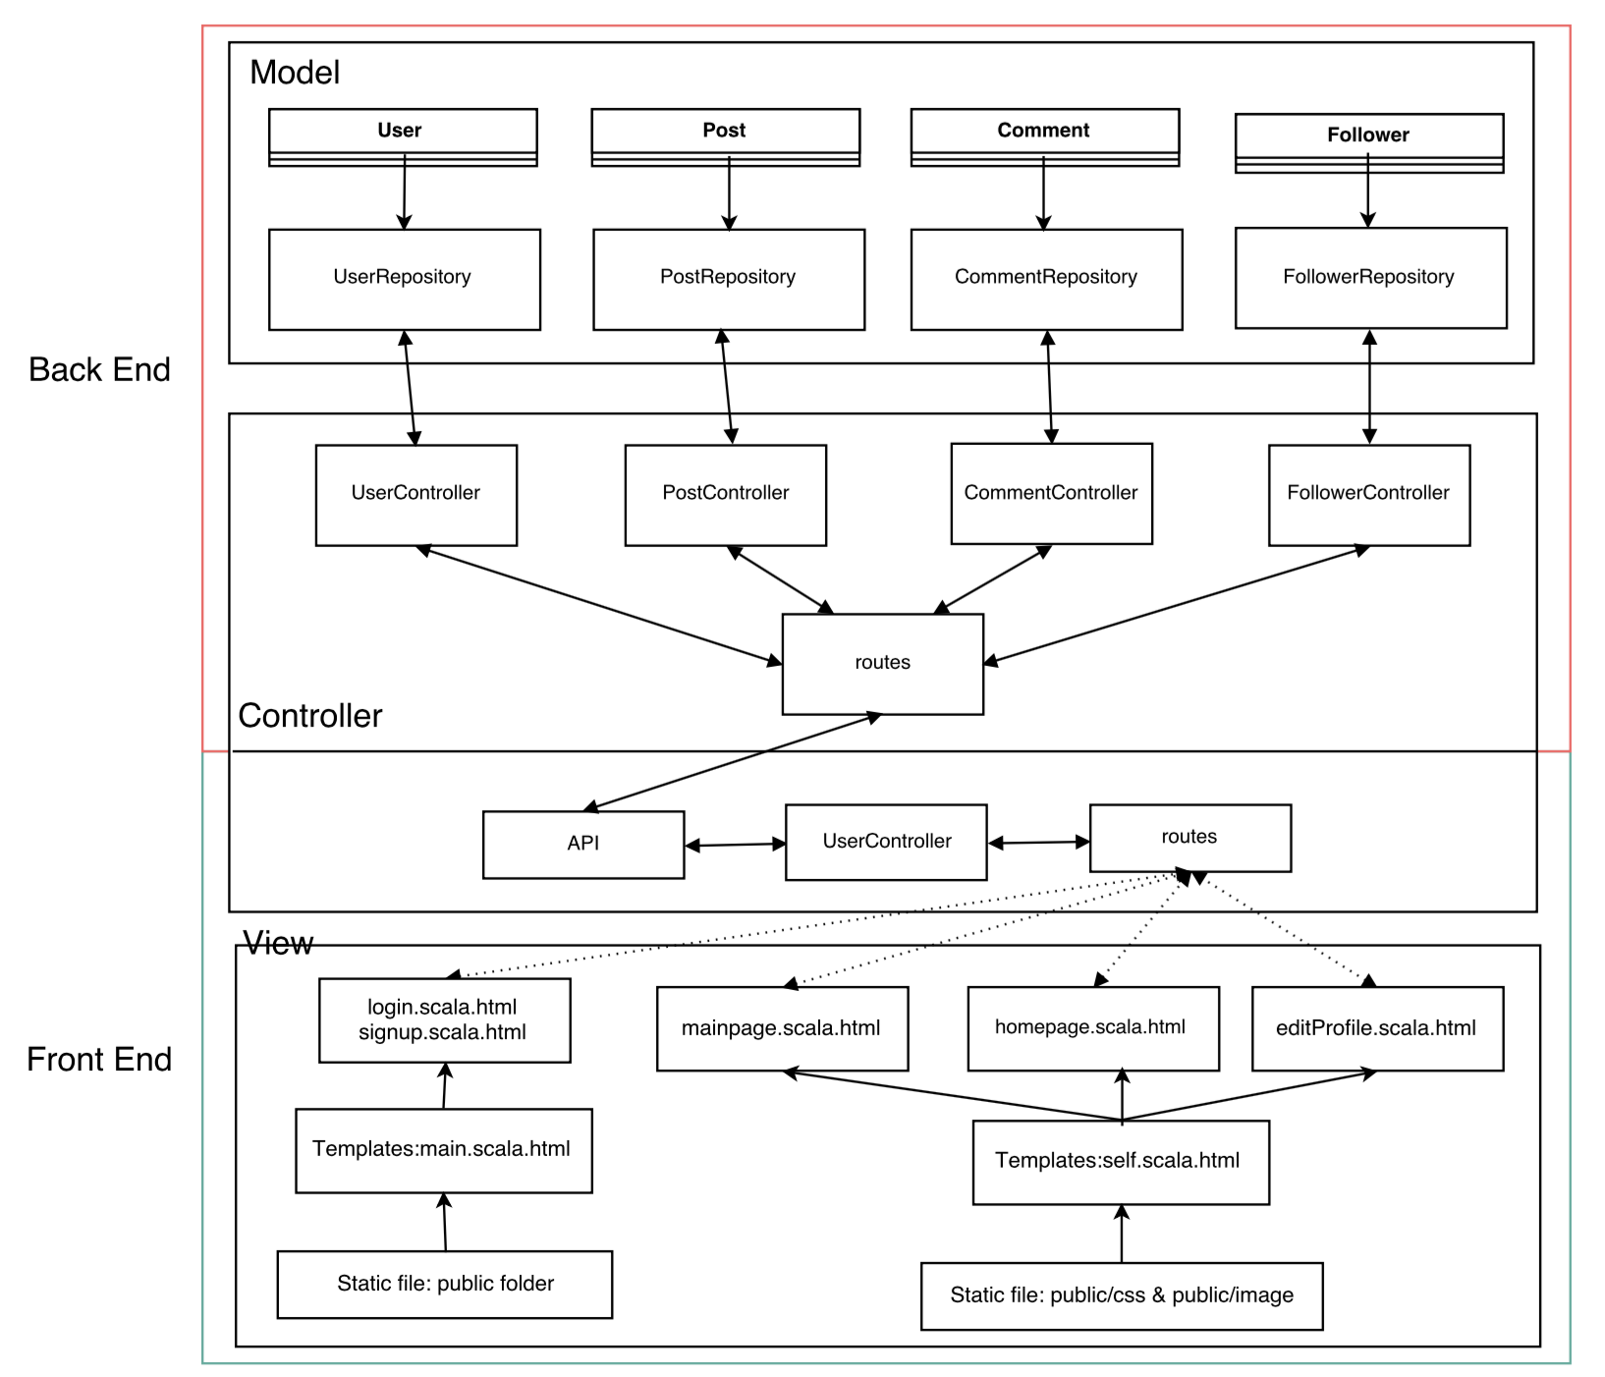

**Front end**

The project is designed based on the MVC architectural pattern, to be more specific, this pattern splits the application into separate layers: the Presentation layer and the Model layer. The Presentation layer is further split into a View and a Controller layer. We divided the application into two parts, the front end and backend, which mean the front end is the presentation layer.

As for the View, at the first place, we design user interface using Play Scala template, which a simple text file that contains small blocks of Scala code and can generate any text-based format, such as HTML, XML. In order to make the UI user friendly and adjust to multiple screen resolution, we implemented Twitter Bootstrap framework. All of the related static file, including images, CSS and Bootstrap source code and etc., are placed in “public” folder and referred those static content in self.scala.html, which is a inherit template in order to reduce code replication. Basically, we create three scala.html file, mainpage.scala.html, homepage.scala.html and editProfile.scala.html to dynamically generate the model representation. (Also use the existing login.scala.html and signup.scala.html for basic login and sign up functionality.)

The core of the project is the Controller, which is a Java class where each public, static, method is an action. Using the URL in “routs” file to map the actions in Controller. In our project, the Controller is named as “UserController”, which contains “mainpage()”, “homepage()”, “addPost()”, “deletePost()”, “sharePost()”, “likePost()”, “searchUser()”, “addComment()”, “editProfile()” actions. In each action, extracts relevant data from the HTTP request and parse the data to JSON, and communicate with the backend using APICALL, then extract the data which is wrapped into response from the backend, usually in JSON format. At last, the updated data will be displayed on the View.

With regard to Model, it is the domain-specific representation of the information on which the application operates. MVC does not specifically mention the data access layer because it is understood to be underneath, or encapsulated by, the Model. In our project, the specific operation on the Model are executed in the backend with the control of UserController, PostController, CommentController and FollowerController. As for the backend, it will be introduced in detail as below.

**Back end**

For back end system design, there are four main models, which are User, Follower, Post and Comment. Each of them corresponds to a table in the MySQL database and has a repository and controller respectively.

At first, here are the screenshots of our design drafts of these models.

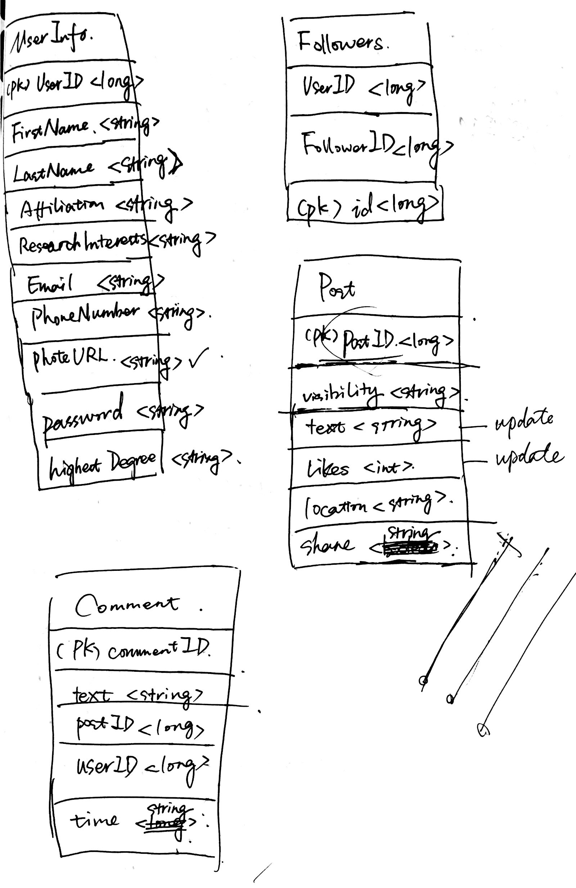

Fig. 1 Design draft of database schema

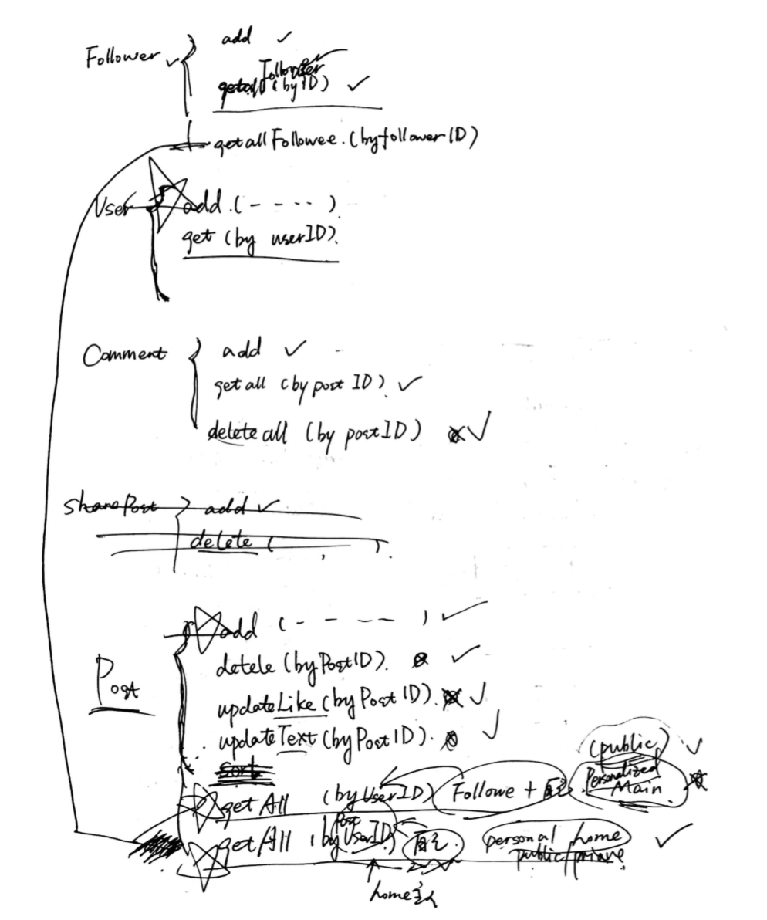

Fig. 2 Design draft of back end implementation methods

Then, here are some detail explanations and screenshots of each class.

1. **User**

For user model, its primary key is the automatic generated id. It has many fields to store the user-related information such as email, password, first name, last name and so on. When there are some operations in the front end that need to check or edit user’s information, such as log in, corresponding methods in User controller will be called. Here are the screenshots of User class and User controller.

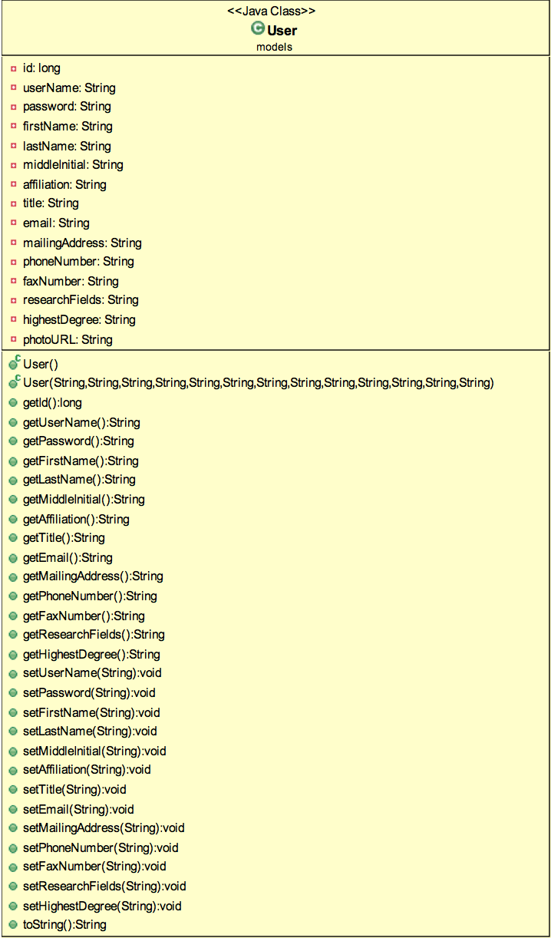

Fig. 3 User class

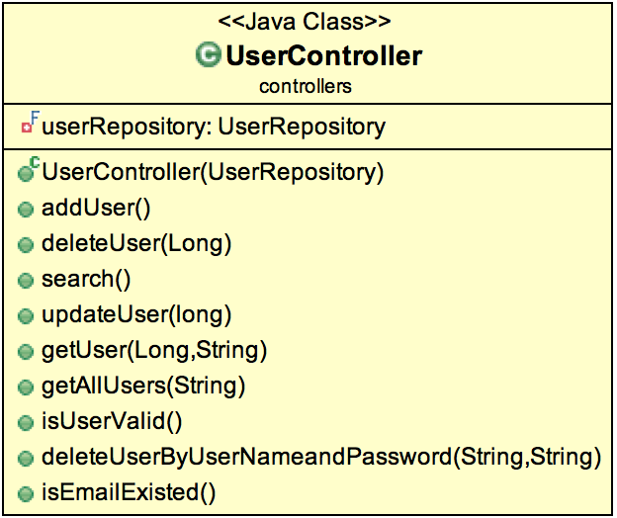

Fig. 4 User controller

1. **Follower**

For follower model, it only has three fields. It uses the automatic generated id as its primary key and has another two fields, user Id and follower Id. This model is used to record all the follower and followee relationship. When there are some operations in the front end that need to check or change user’s follower/followee information, such as following a new person, corresponding methods in Follower controller will be called. Besides, it relates with User model closely by using the id fields. Here are the screenshots of Follower class and Follower controller.

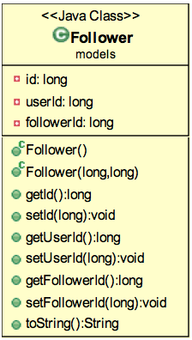

Fig. 5 Follower class

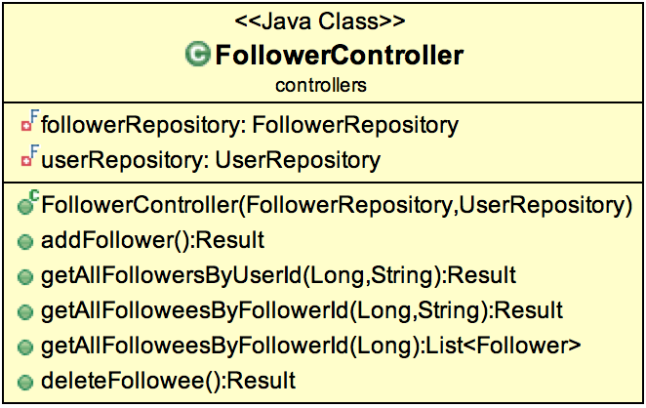

Fig. 6 Follower controller

1. **Post**

As for post model, it also has an automatic generated id as its primary key. Considering all the post-related operations, like publishing public/private posts, edit/like/delete/share posts and share location, post model has ten fields altogether including id. Each of these fields is used to store post-related operation information. When there are some operations in the front end that need to change post information, such as publishing a new post, corresponding methods in Post controller will be called. Here are the screenshots of Post class and Post controller.

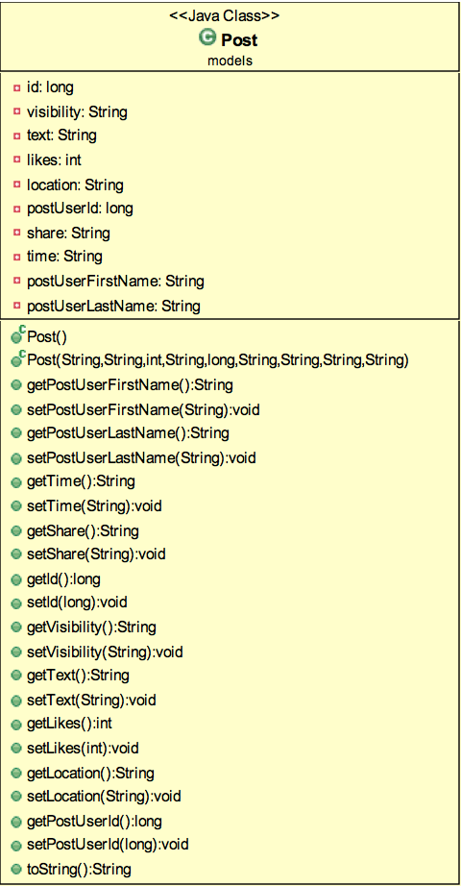

Fig. 7 Post class

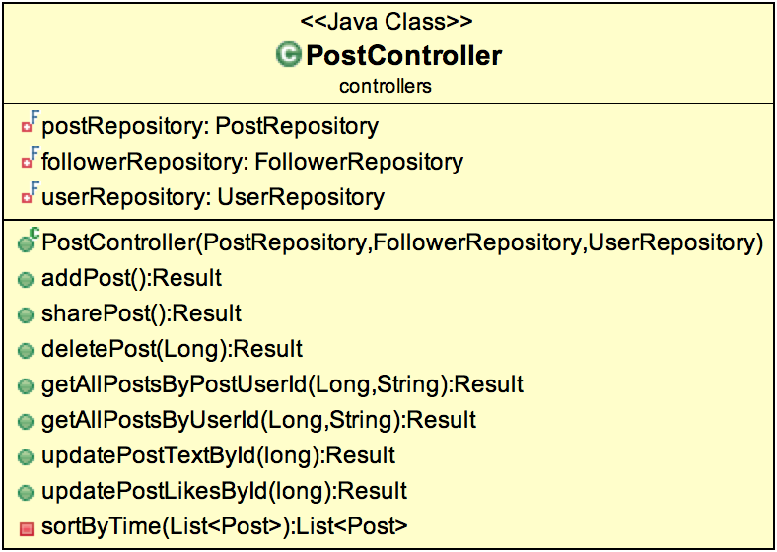

Fig. 8 Post controller

1. **Comment**

At last, for comment model, like others, it sets an automatic generated id as its primary key. Except for that, it has a post Id field to recognize which post it belongs to, user information fields to specify who adds this comment and a time field to record when it is added. Comment class is related to Post class closely using the field post Id. When there are some operations in the front end that need to check or add comments, corresponding methods in Comment controller will be called. Here are the screenshots of Comment class and Comment controller.

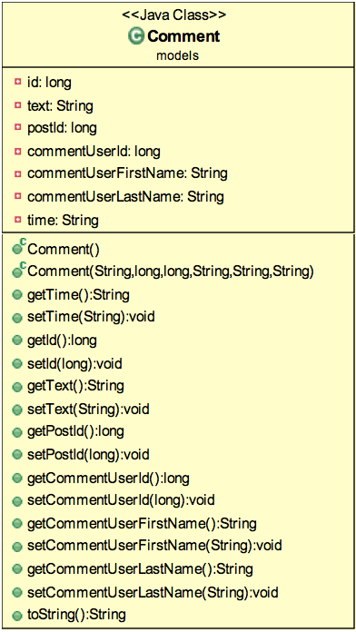

Fig. 9 Comment class

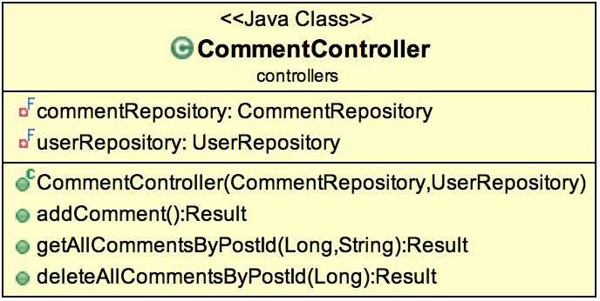

Fig. 10 Comment controller

Finally, following is the screenshot of our final database schema. From this picture, we can see the detail information of each table and the relationship between them.

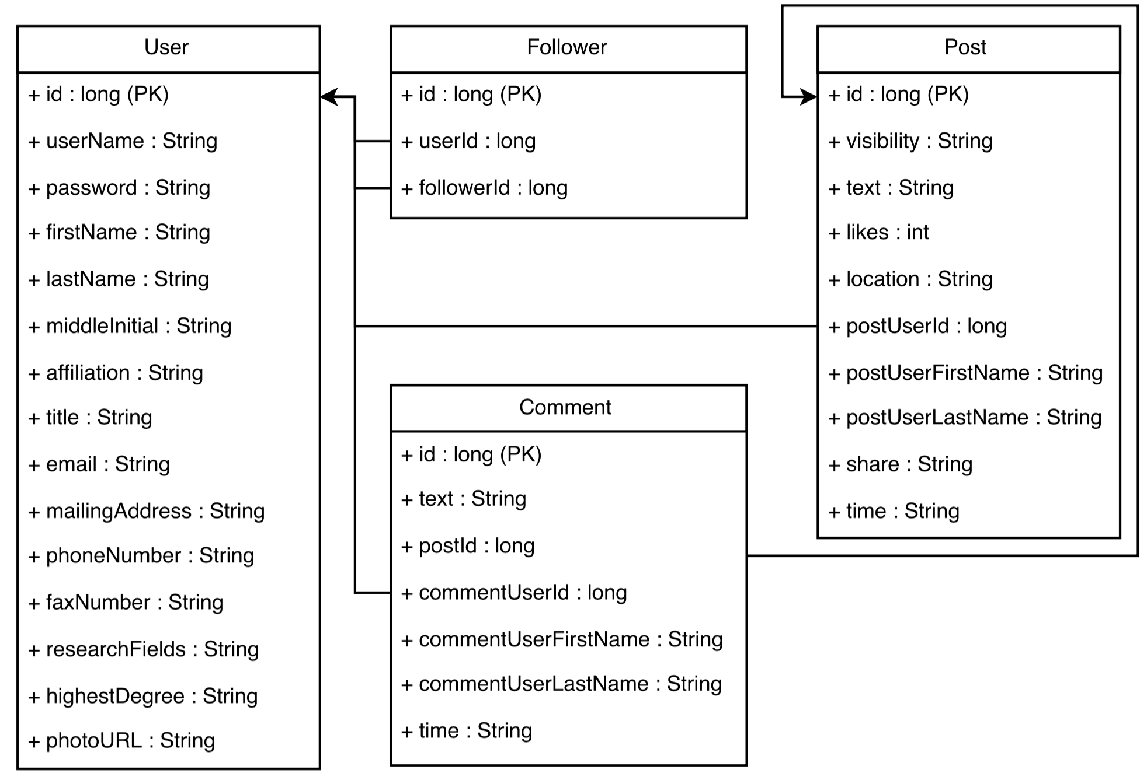

Fig. 11 Final database schema

1. **System Implementation**

As you have read in the previous section, we have great design for our system and now we will introduce to you the system implementation of our project.

In this section, we are going to talk about how we have implemented our project. The logic of this section is that we first going to introduce the technologies in this project we have used, one by one, both in backend and frontend. The programing languages we have used in different modules. Also we will show you the database technology we have used and implemented.

**Back End**



Programing language: Java

Java is one of the best programming language created ever, which has been proved it in last 20 years. Two decades is a big time for any Programming language, and Java has gained strength every passing day.

Earlier with ground-breaking changes in form of Enum, Generics, and Autoboxing in Java 5, performance improvement with Java 6, and Google's choice of language for Android apps development, keeps Java as front line programming language.

For our project, the team members in backend all have great experience in Java programing so the development period is very fluent.



Database: MySQL

MySQL is a very popular open source relational database, which is also popular choice of database for use in web applications. It is a central component of the widely used LAMP open source web application software stack (and other "AMP" stacks). LAMP is an acronym for "Linux, Apache, MySQL, Perl/PHP/Python." Free-software-open source projects that require a full-featured database management system often use MySQL.

For our project, we have use MySQL as our backend database. We have adopted the advantages of this structured relational database to store the information in our project and designed database schema for the models in our project, which has been thoroughly explained in the system design section.



Mapping Framework: Hibernate

Hibernate ORM, Hibernate in short, is an object-relational mapping framework for the Java language, providing a framework for mapping an object-oriented domain model to a traditional relational database. Hibernate solves object-relational impedance mismatch problems by replacing direct persistence-related database accesses with high-level object handling functions.

By using this mapping framework in our project, we have successfully mapped the models created in java to tables in our MySQL database schema.

**Front End**



Web Application Framework: Play

Play is an open source web application framework, written in Scala and Java, which follows the model–view–controller (mvc) architectural pattern. It aims to optimize developer productivity by using convention over configuration, hot code reloading and display of errors in the browser. Support for the Scala programming language has been available since version 1.1 of the framework. In version 2.0, the framework core was rewritten in Scala. Build and deployment was migrated to SBT, and templates use Scala instead of Groovy.

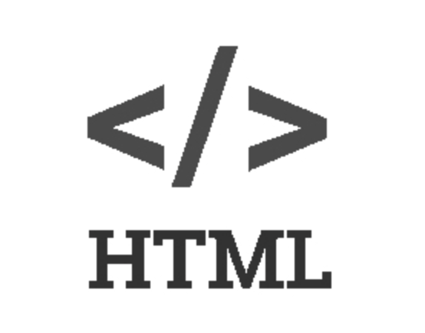

Markup Language: HTML

HyperText Markup Language, commonly referred to as HTML, is the standard markup language used to create web pages. Along with CSS, and JavaScript, HTML is a cornerstone technology, used by most websites to create visually engaging webpages, user interfaces for web applications, and user interfaces for many mobile applications.[1] Web browsers can read HTML files and render them into visible or audible web pages. HTML describes the structure of a website semantically along with cues for presentation, making it a markup language, rather than a programming language.



Style sheet Language: CSS

Cascading Style Sheets (CSS) is a style sheet language used for describing the presentation of a document written in a markup language. Although most often used to set the visual style of web pages and user interfaces written in HTML and XHTML, the language can be applied to any XML document, including plain XML, SVG and XUL, and is applicable to rendering in speech, or on other media. Along with HTML and JavaScript, CSS is a cornerstone technology used by most websites to create visually engaging webpages, user interfaces for web applications, and user interfaces for many mobile applications.



Language: JavaScript

JavaScript is a high-level, dynamic and interpreted programming language. Alongside HTML and CSS, it is one of the three essential technologies of World Wide Web content production; the majority of websites employ it. It has been supported by all modern web browsers without plug-ins.



Framework: Bootstrap

Bootstrap is a sleek, intuitive, and powerful mobile first front-end framework for faster and easier web development.

**Collaboration Tools**

Collaboration: GitHub

GitHub is a Web-based Git repository hosting service. It offers all of the distributed revision control and source code management (SCM) functionality of Git as well as adding its own features. Unlike Git, which is strictly a command-line tool, GitHub provides a Web-based graphical interface and desktop as well as mobile integration. It also provides access control and several collaboration features such as bug tracking, feature requests, task management, and wikis for every project. GitHub offers both plans for private repositories and free accounts, which are usually used to host open-source software projects. As of 2015, GitHub reports having over 11 million users and over 29.4 million repositories, making it the largest host of source code in the world.

During this project, we have successfully adopted the GitHub as our main codes sharing tool. In each sprint period, we committed our newest code to GitHub repository and commented properly to log the entire process of our development.

Here is a screen shot of our GitHub repository.

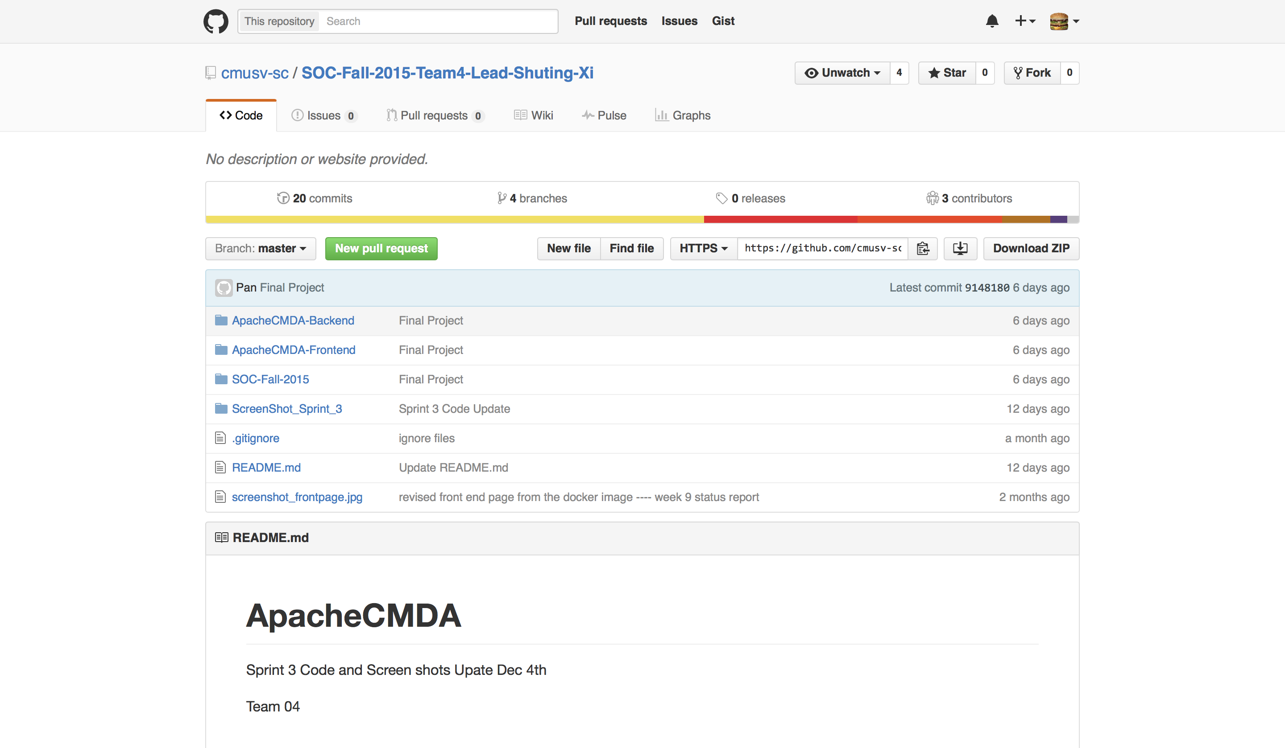

And another screen shot of the commitment to the GitHub repository we have done for this project.

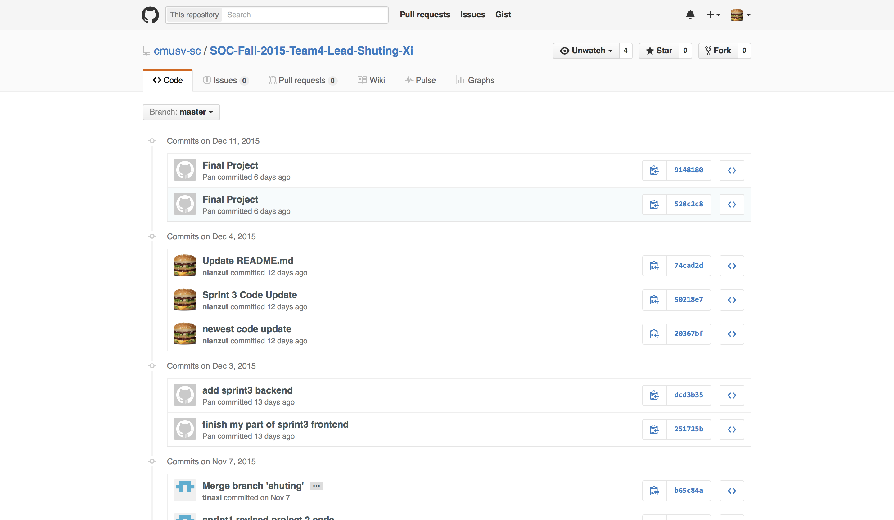

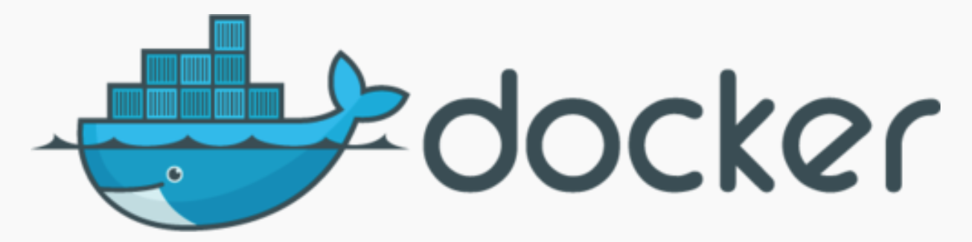

Collaboration Tool: DockerHub

Docker is an open-source project that automates the deployment of applications inside software containers, by providing an additional layer of abstraction and automation of operating-system-level virtualization on Linux. Docker uses resource isolation features of the Linux kernel such as cgroups and kernel namespaces to allow independent "containers" to run within a single Linux instance, avoiding the overhead of starting and maintaining virtual machines.

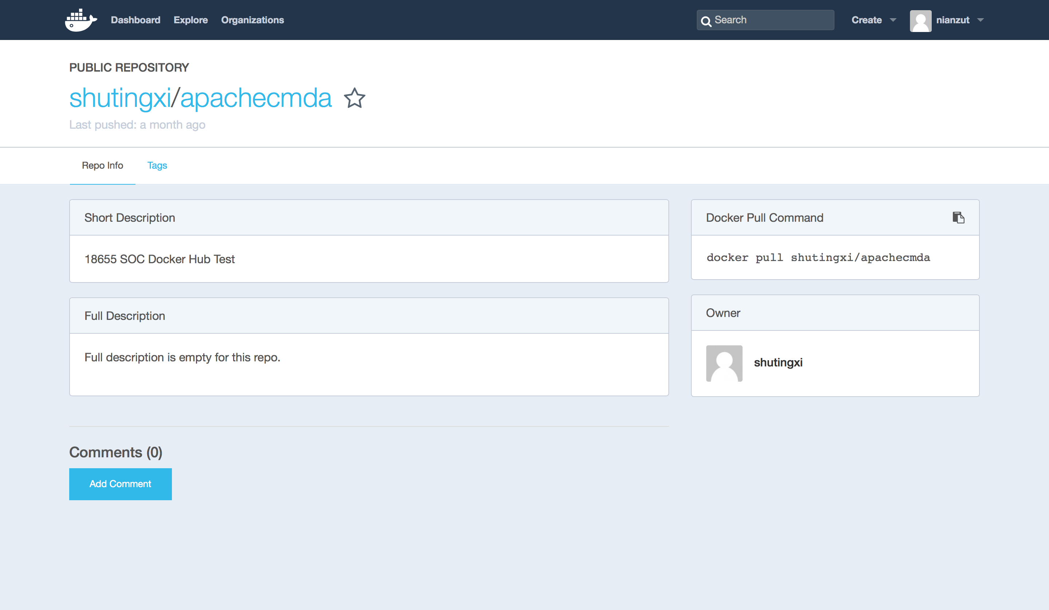

We use DockerHub to collaborate with each of the teammates and store the project image. Here is a screenshot of our DockerHub reporsitory.



Collaboration Tool: Trello

Trello is a web-based project management application originally made by Fog Creek Software in 2011, that spun out to be its own company in 2014. It operates a freemium business model, as well as being cross-subsidized by other Fog Creek Software products. A basic service is provided free of charge, although a Business Class paid-for service was launched in 2013.

Here is a screen shot of our Trello board. We use trello as our main scheduler through our entire process of our development period.

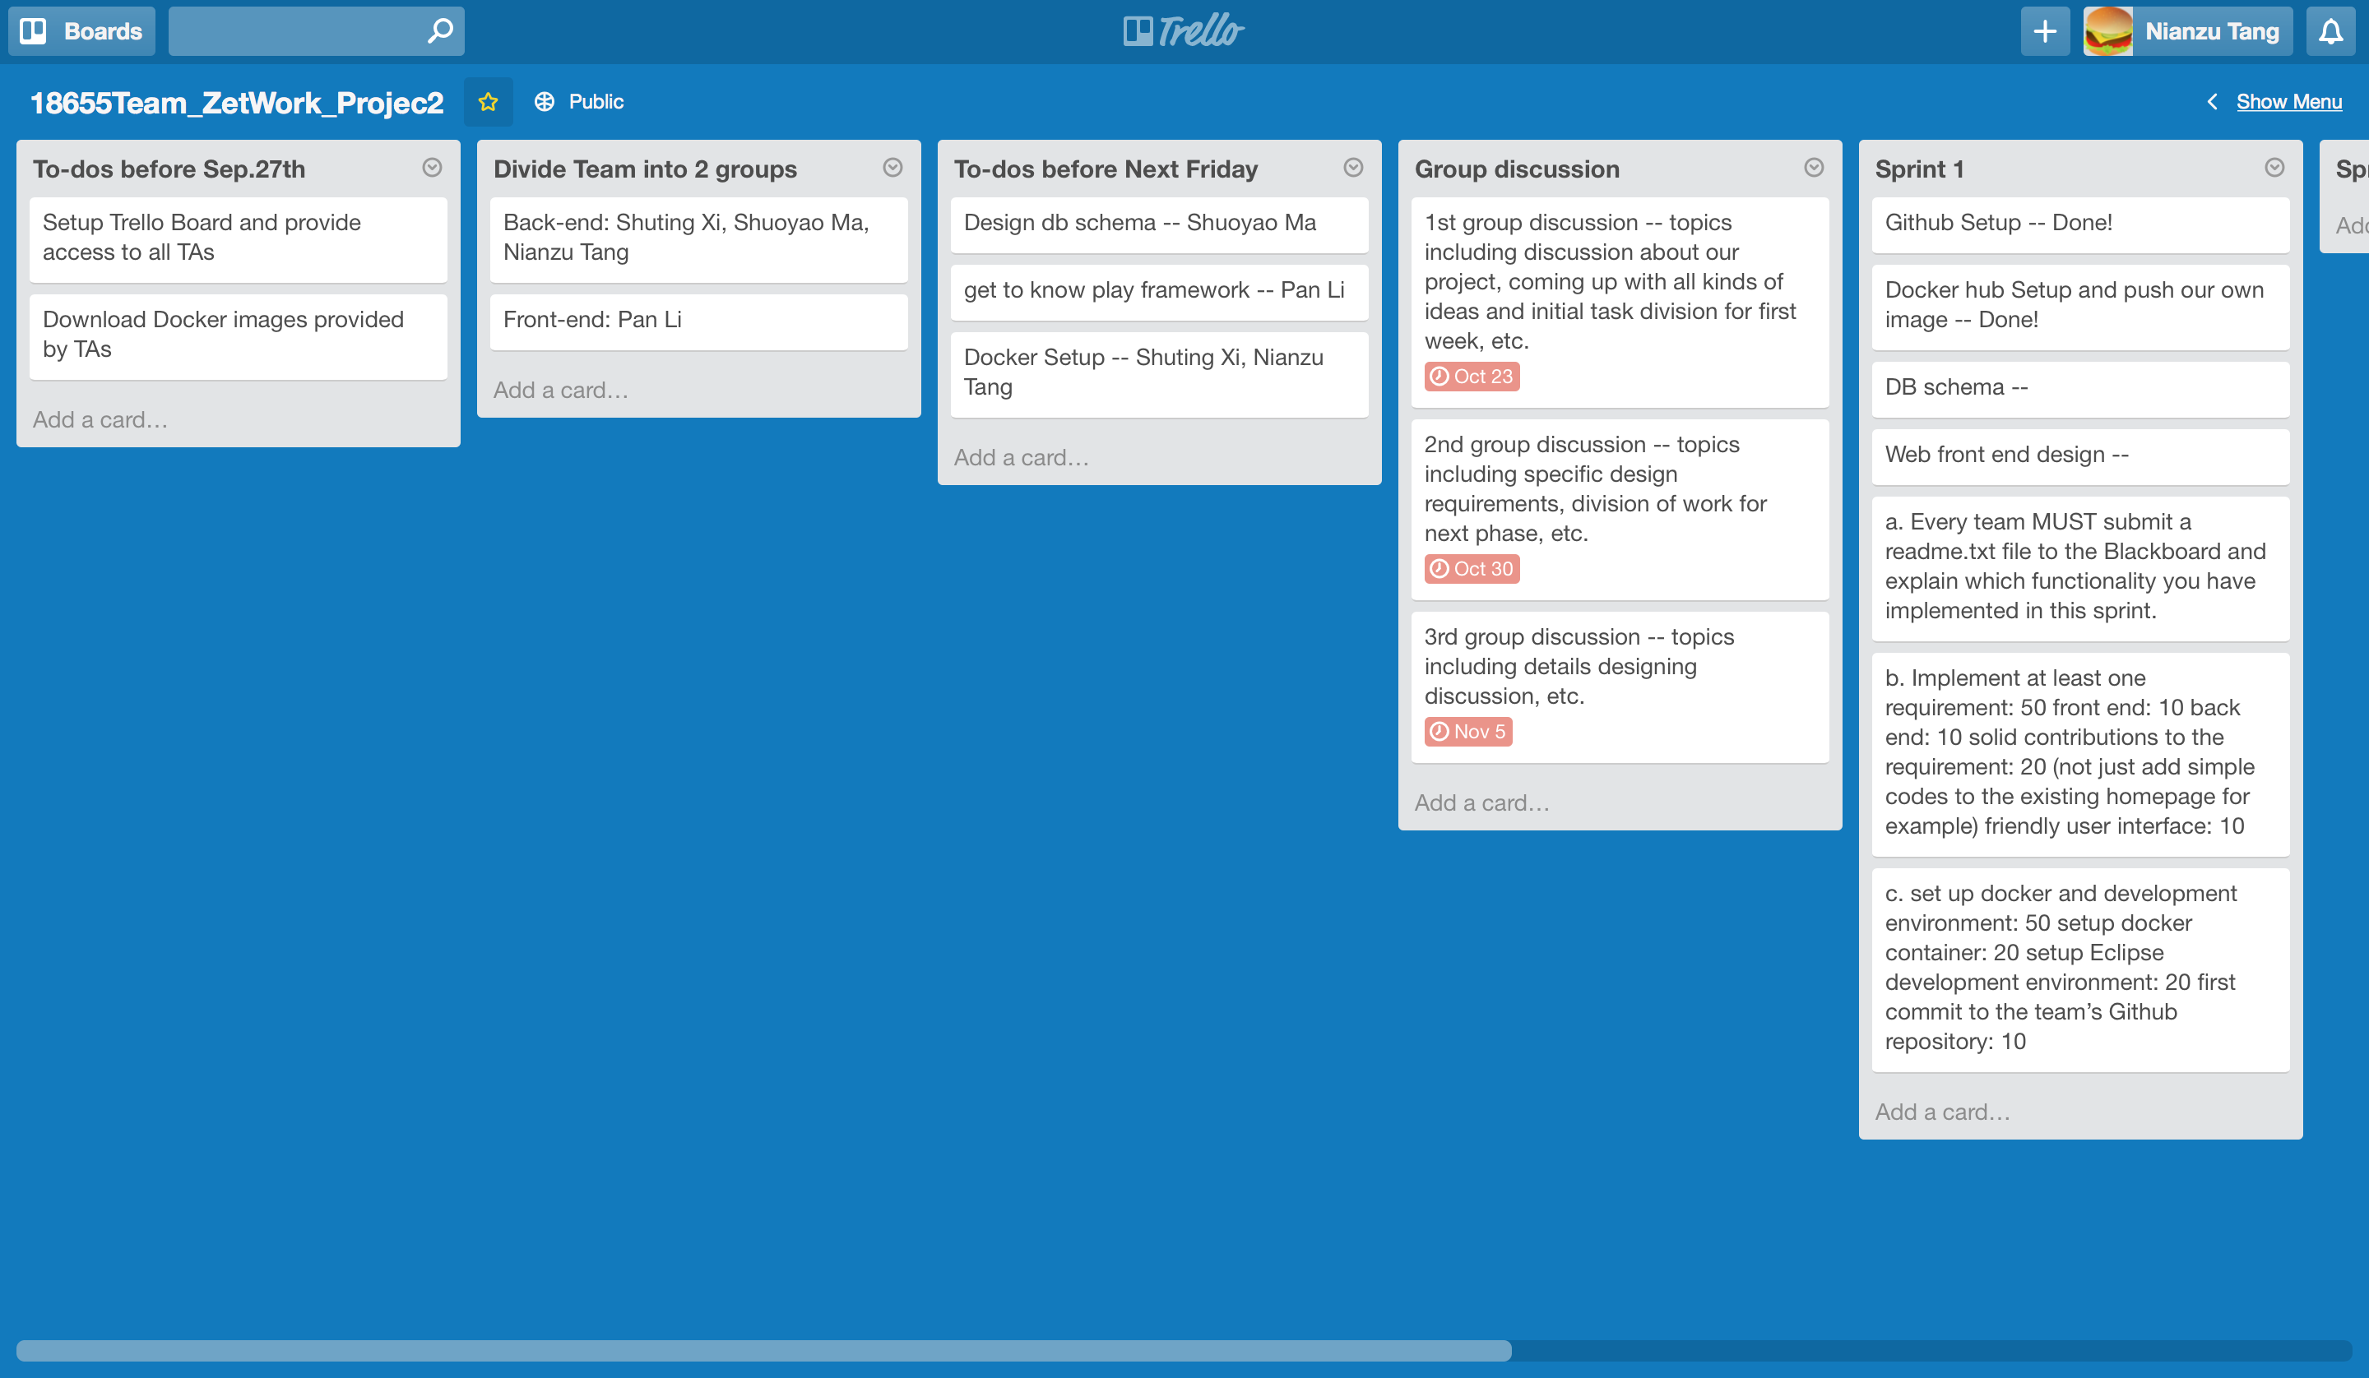

1. **Experiments and Analysis**

(1) Sign Up

To sign up, just click the sign up page and fill in the required information, then you click the submit button, you will get a sign up success page, and your registration has been success.

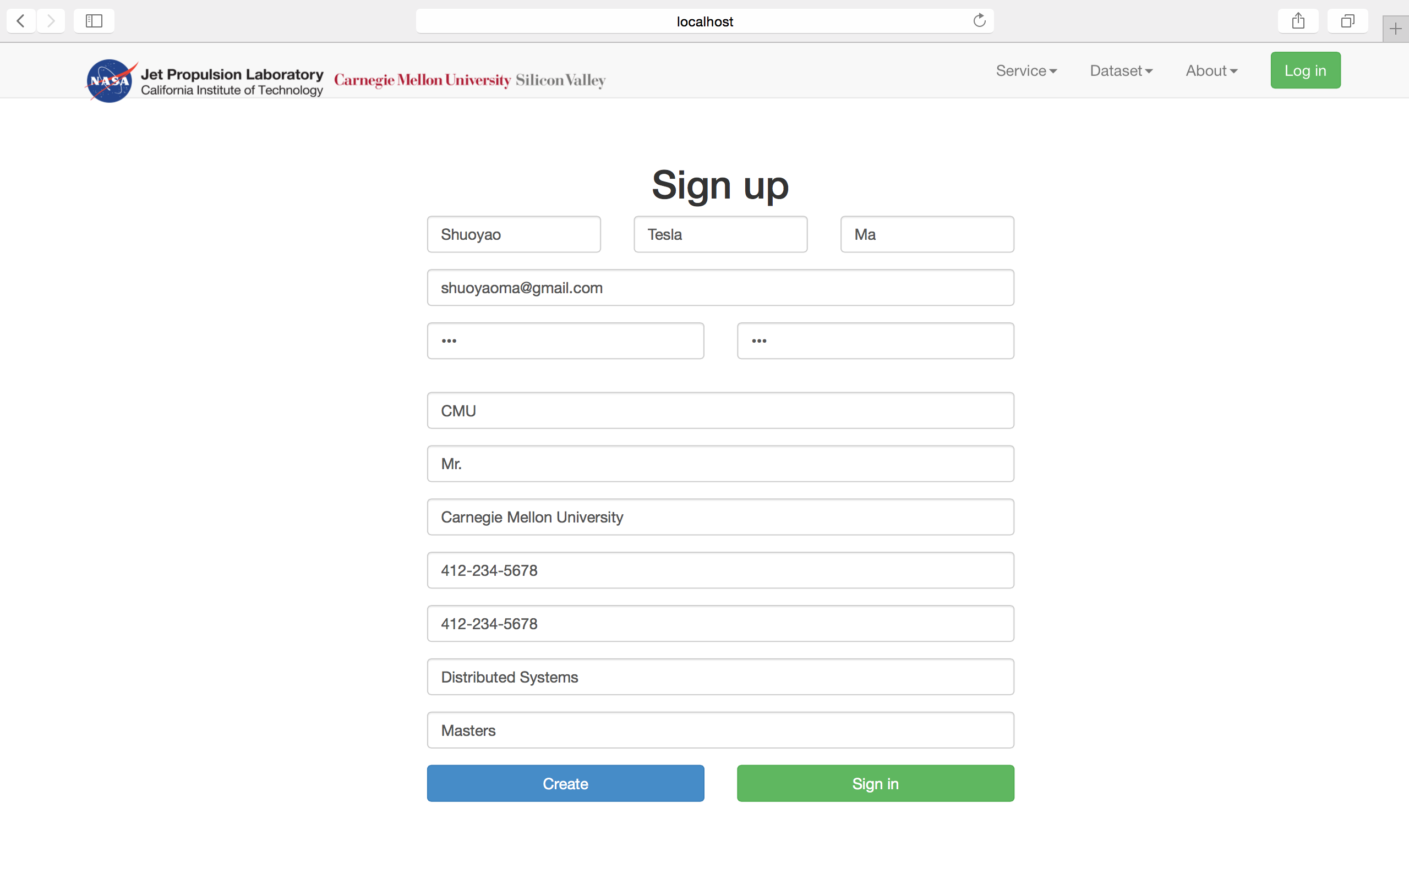

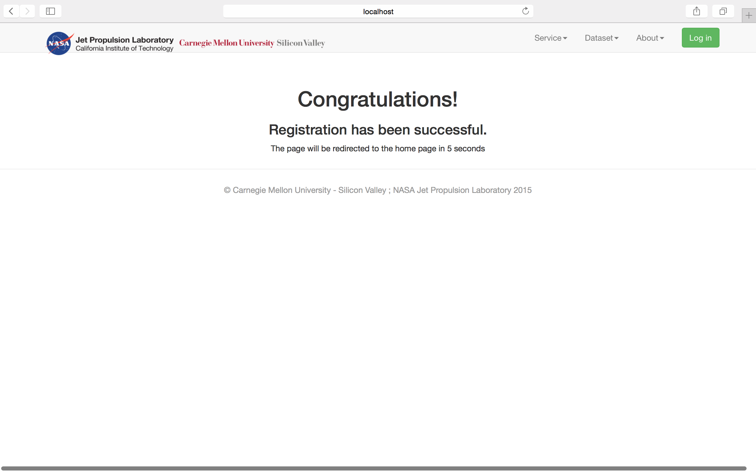

(2) Sign In

After you have signed up, you can use your email address and password to sign in:

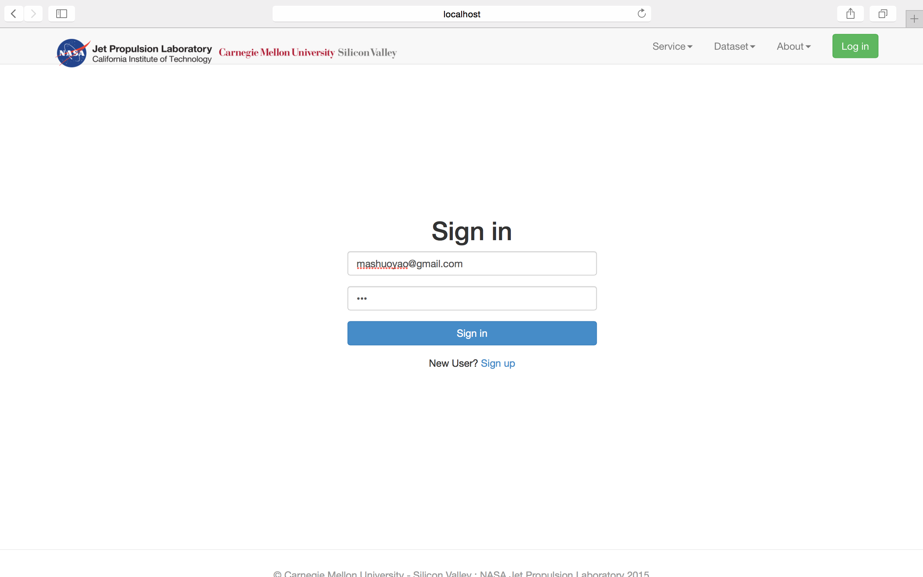

(3) Main Page

After you have signed in, you will see your main page

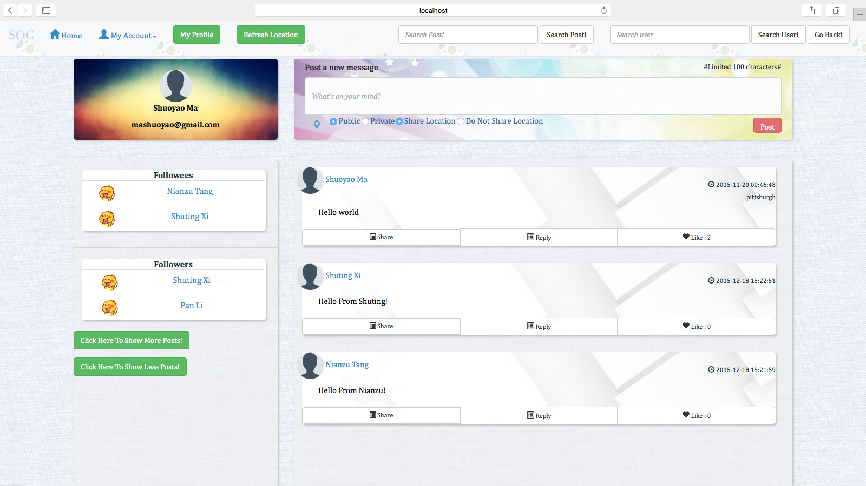

(4) Home Page

When you click a user name or you click the my profile button, you will see the home page of a user:

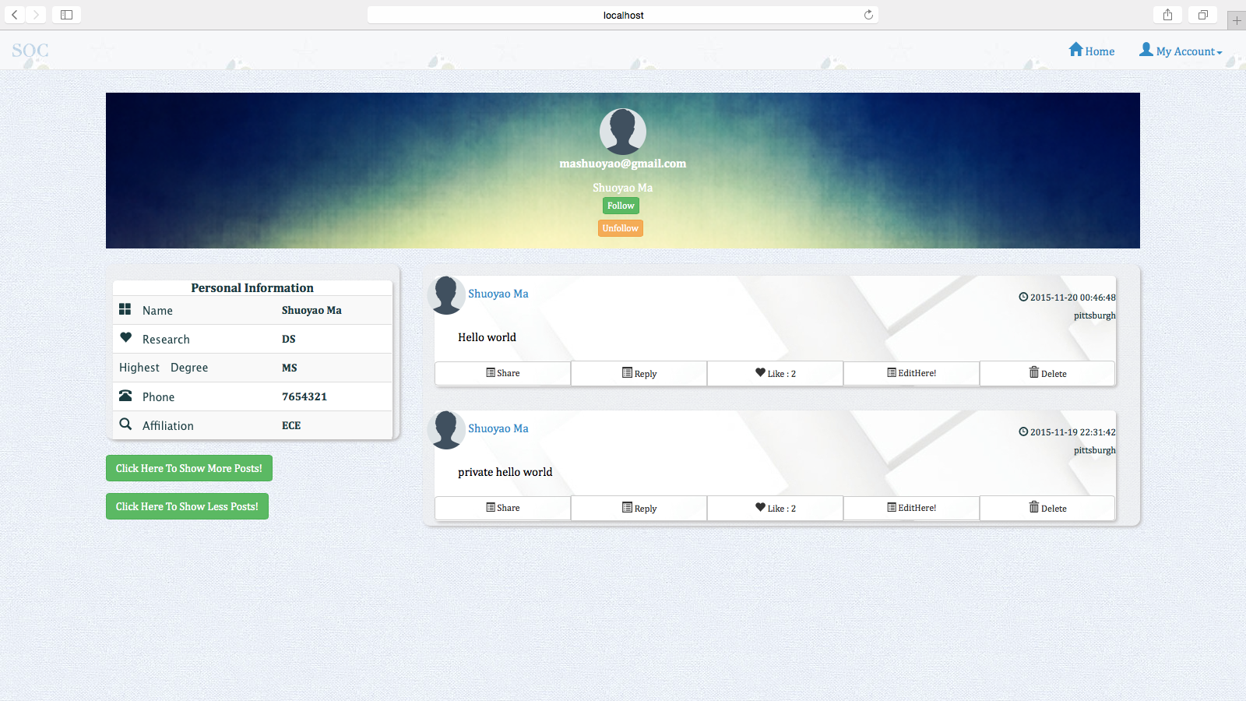

(5) Add Post

There are many options to add post.

Post added in private will not be seen in the main page, but can be seen in the user’s own home page. In the following screen shots, the post “Hello from Shuoyao - Private” is added, but can be only seen in Shuoyao’s home page when Shuoyao logs in.

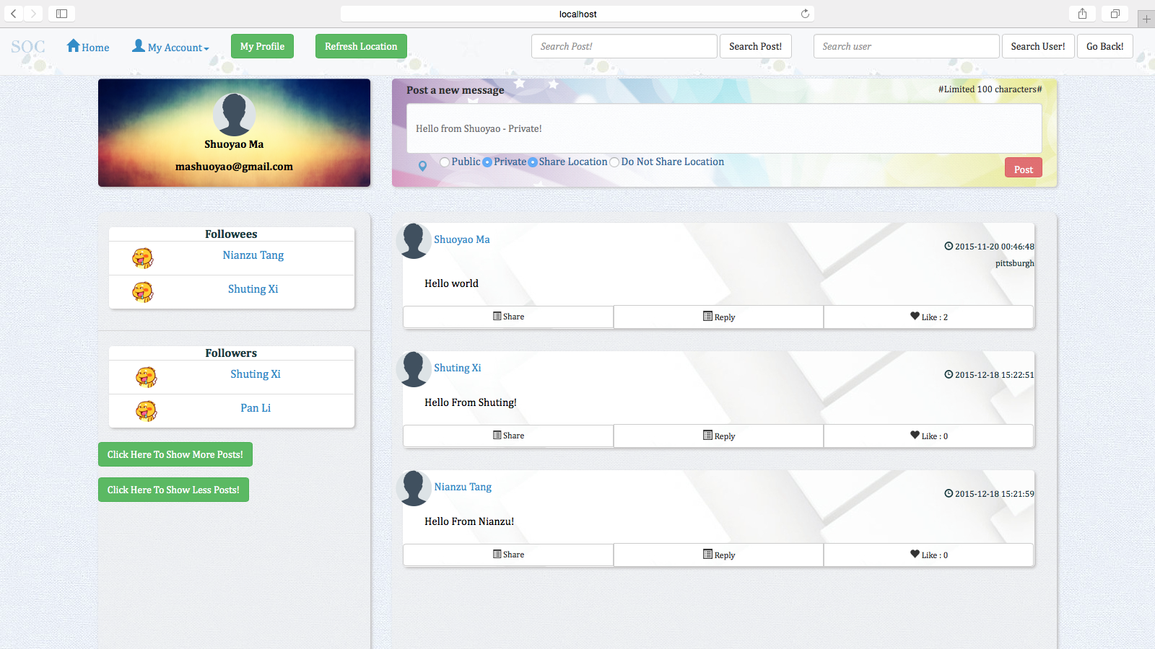

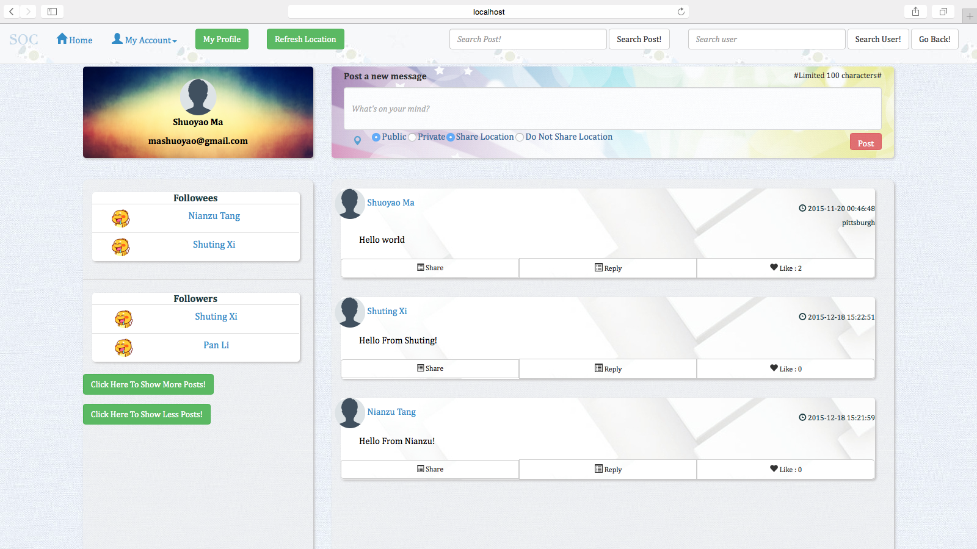

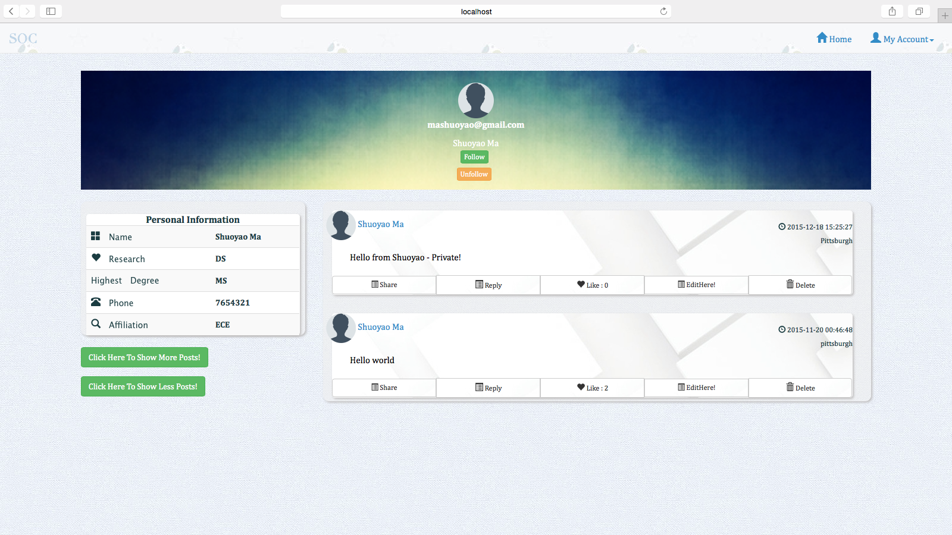

Post Added in public will be seen by others in the main page. The Post “Hello World” Posted by Shuoyao has been seen in the main page and also in the home page.

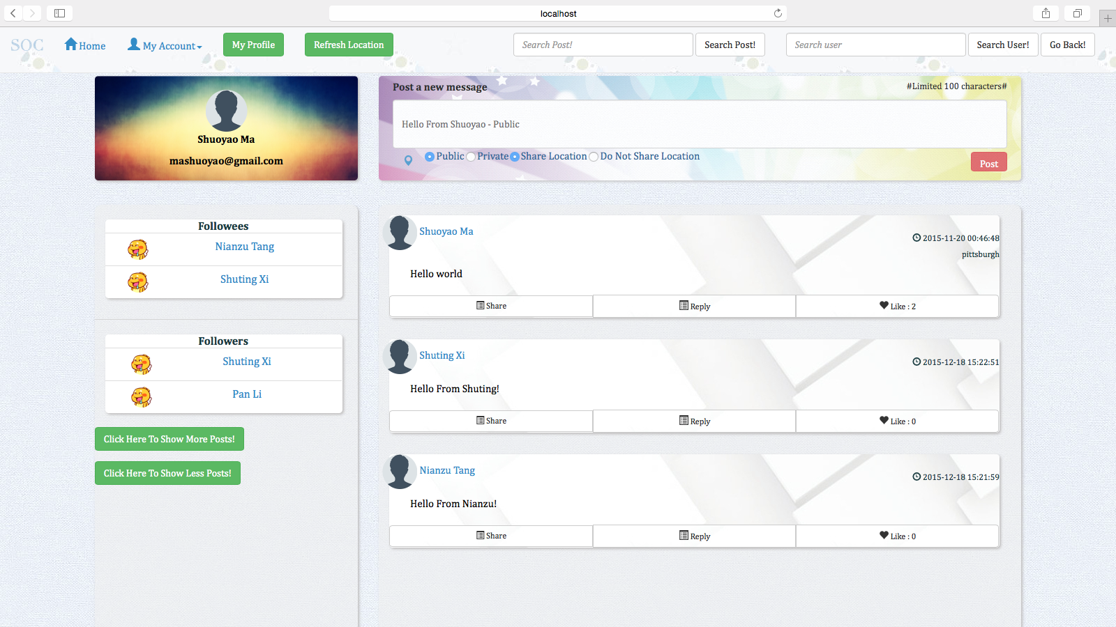

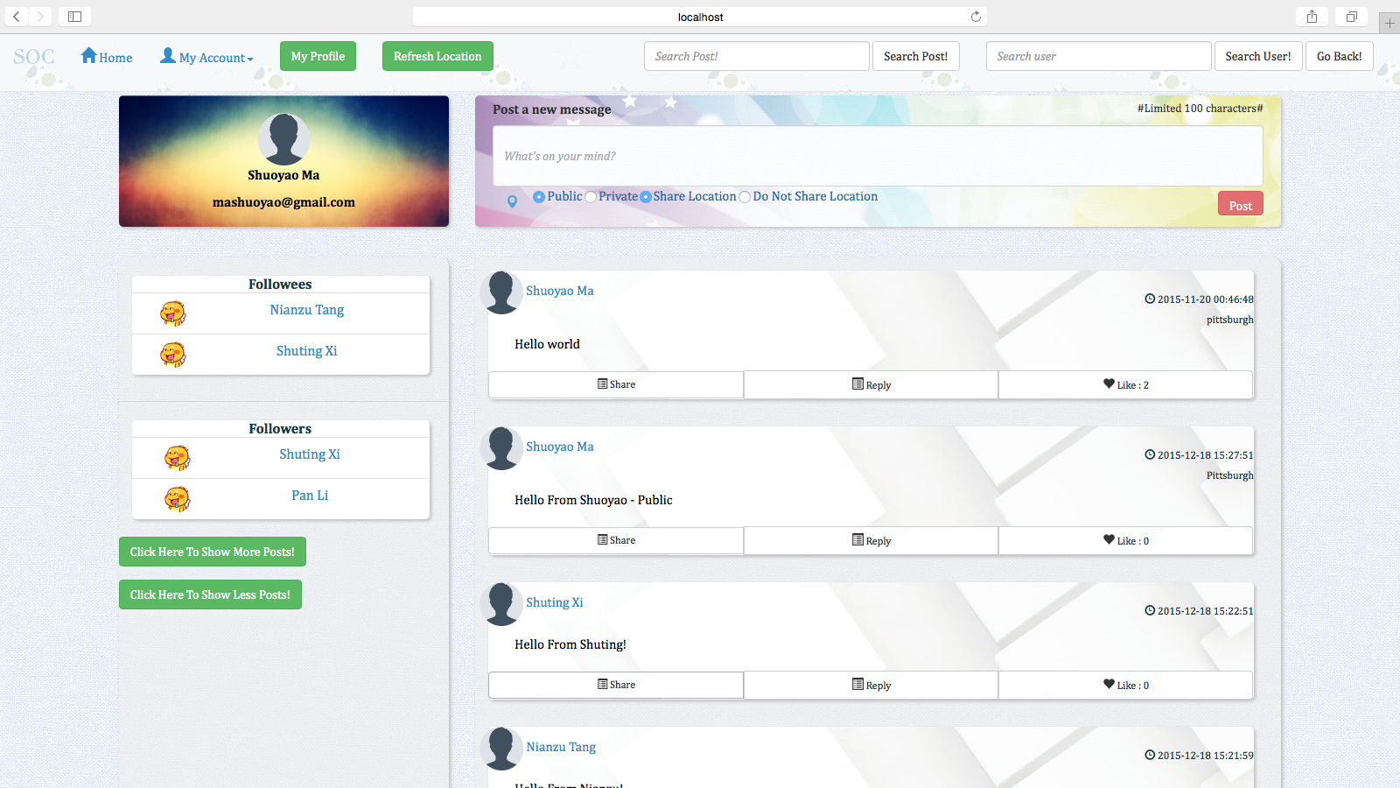

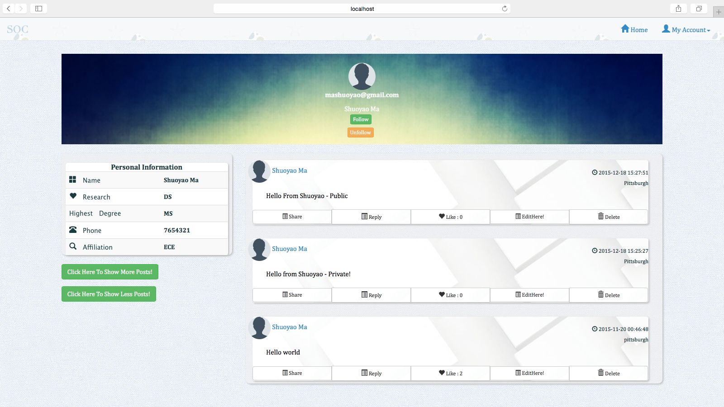

There is also an option that you can choose to add post but do not share your location, the post without the location is posted when the user chose the “Do Not Share Location” option when posting:

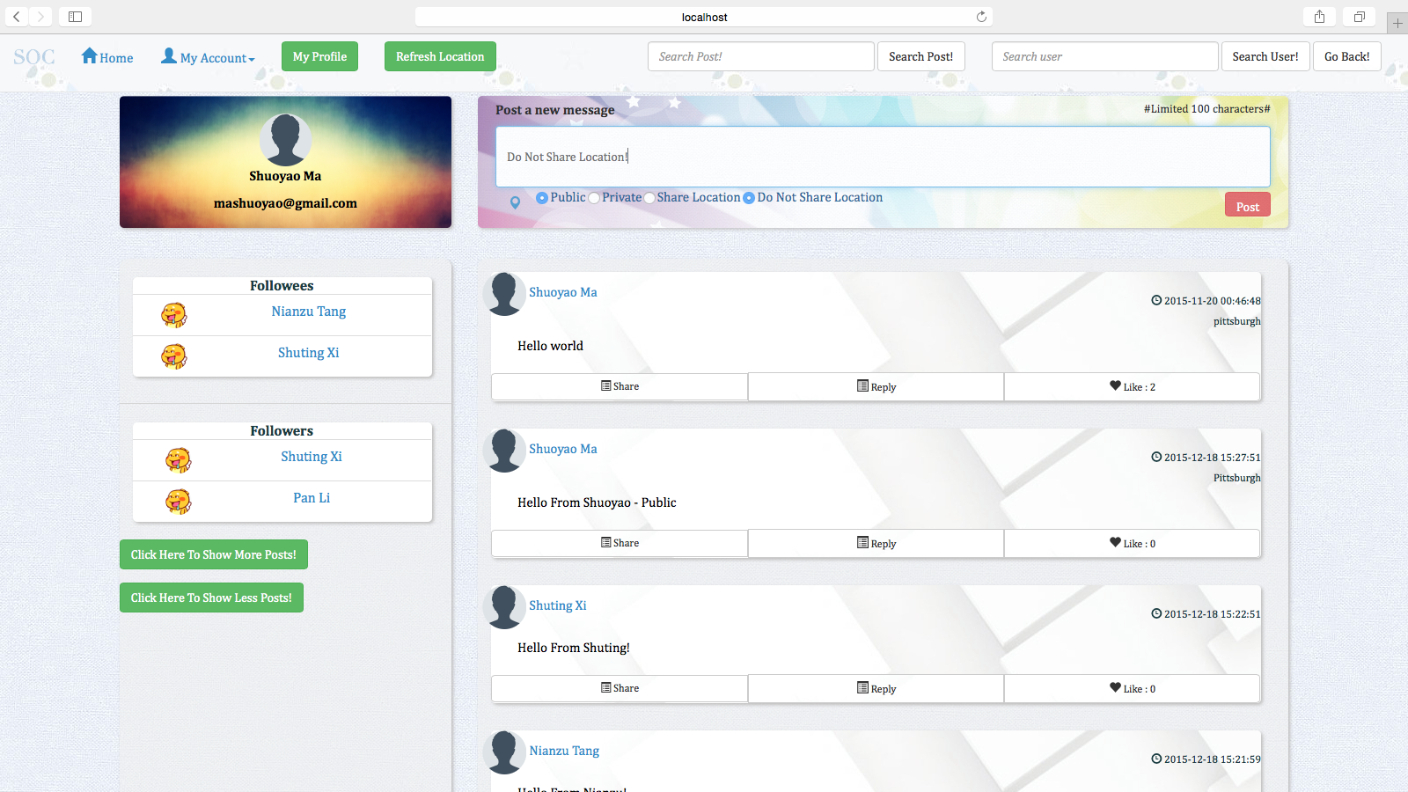

(6) Delete Post

The user can delete his/her post in his/her own home page, you can see, the post “Hello World” Has been deleted:

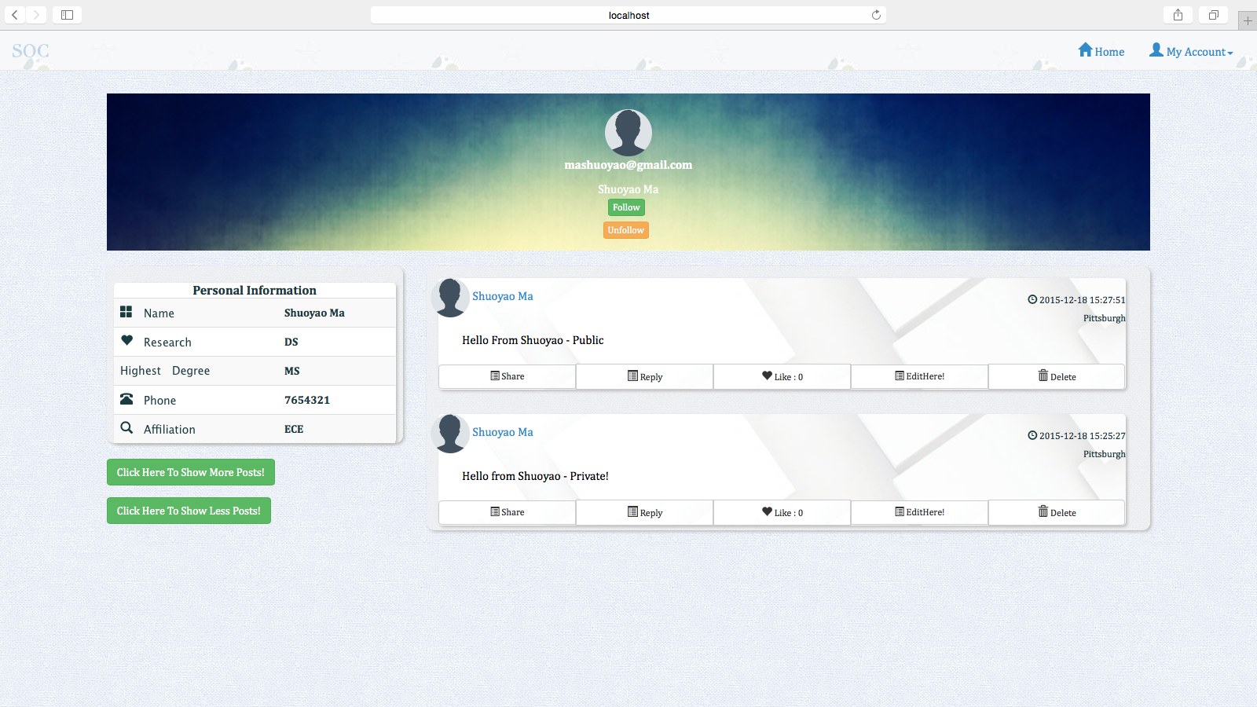

(7) Like Post

A user can like a post, you can see, the post “Hello From Shuoyao - Public” has been liked, it has 1 like:

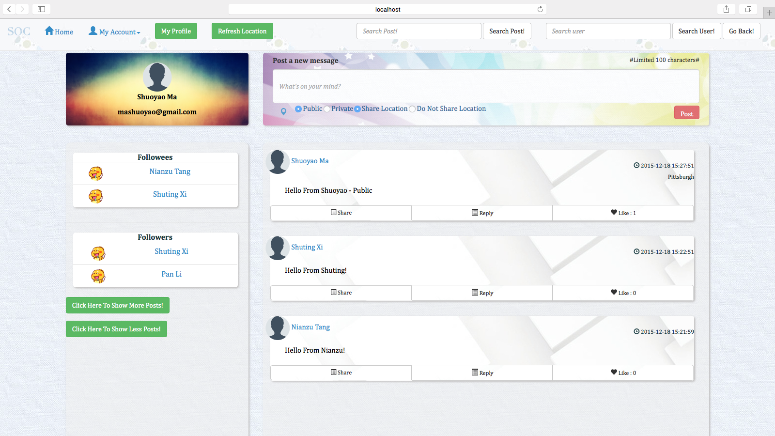

(8) Comment Post

A user can comment the post of other users, you can see, Shuoyao has commented Shuting’s Post:

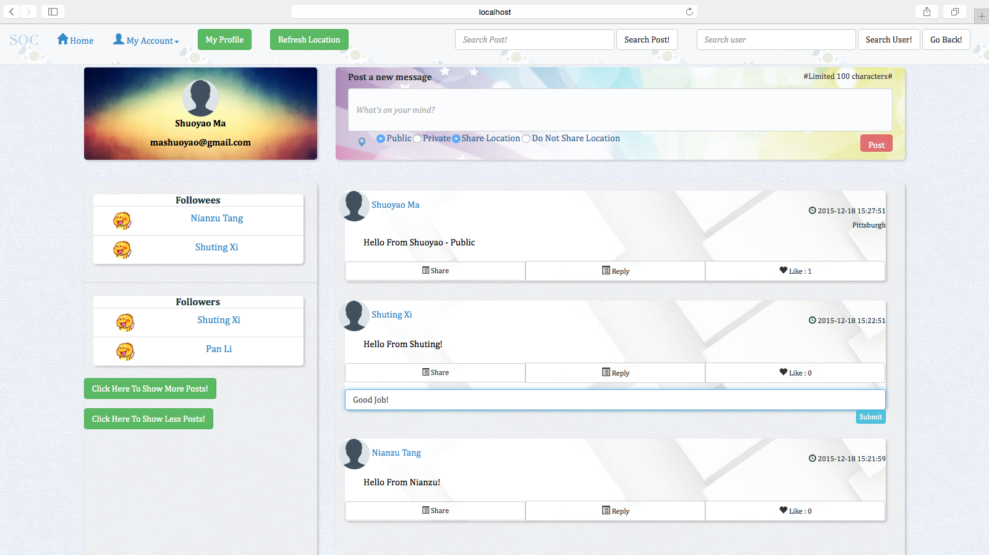

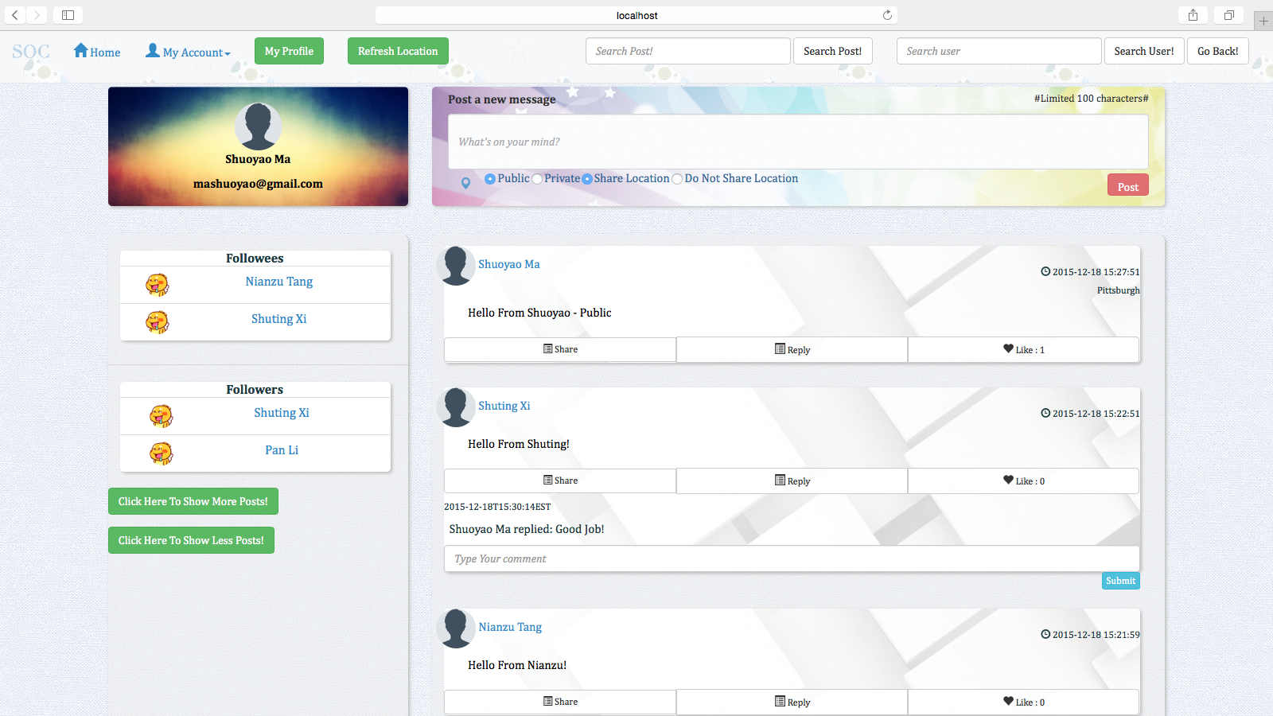

(9) Share Post

A user can share the post of another user, you can see, Shuoyao has shared the post of Nianzu:

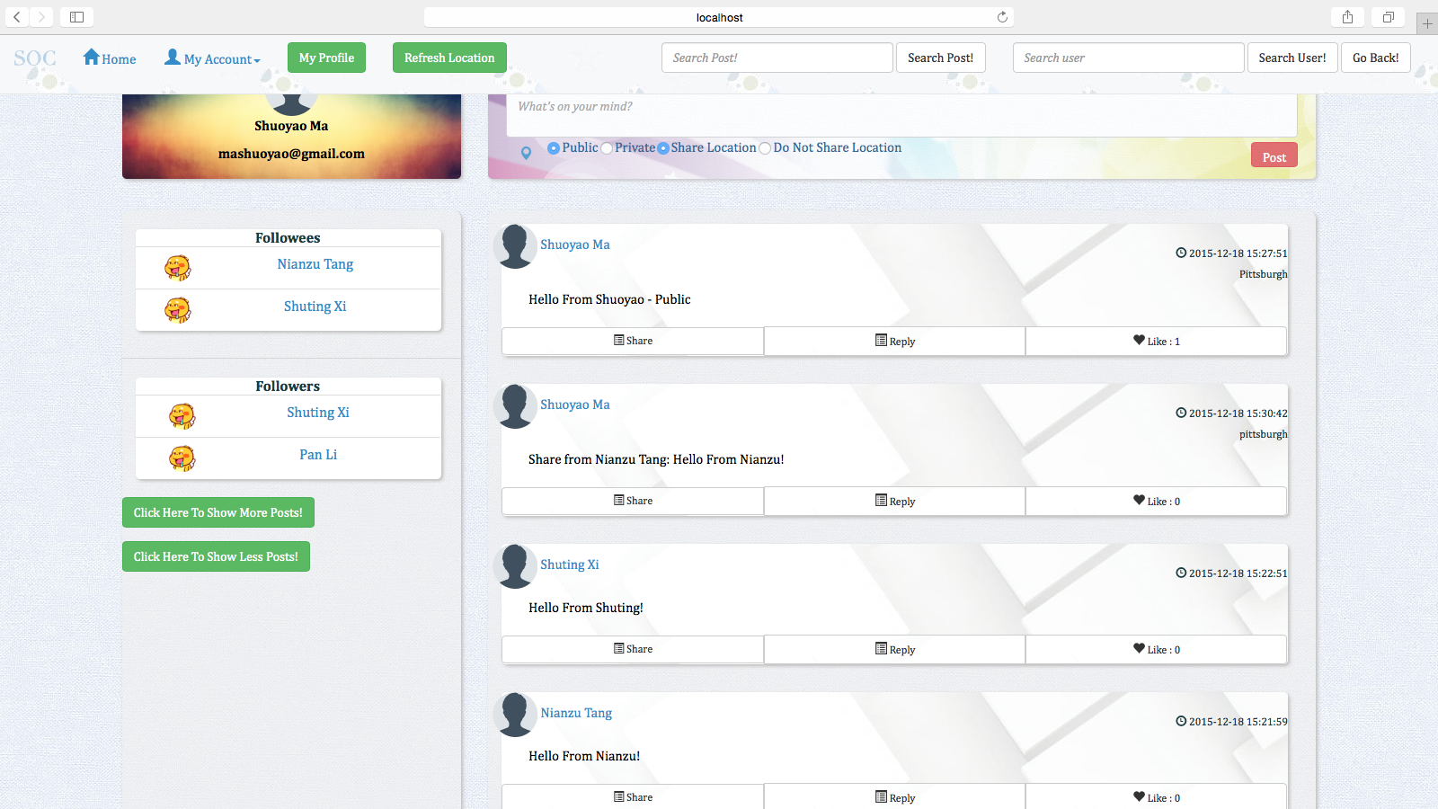

(10) Edit Post

A user can edit post in his/her own home page:

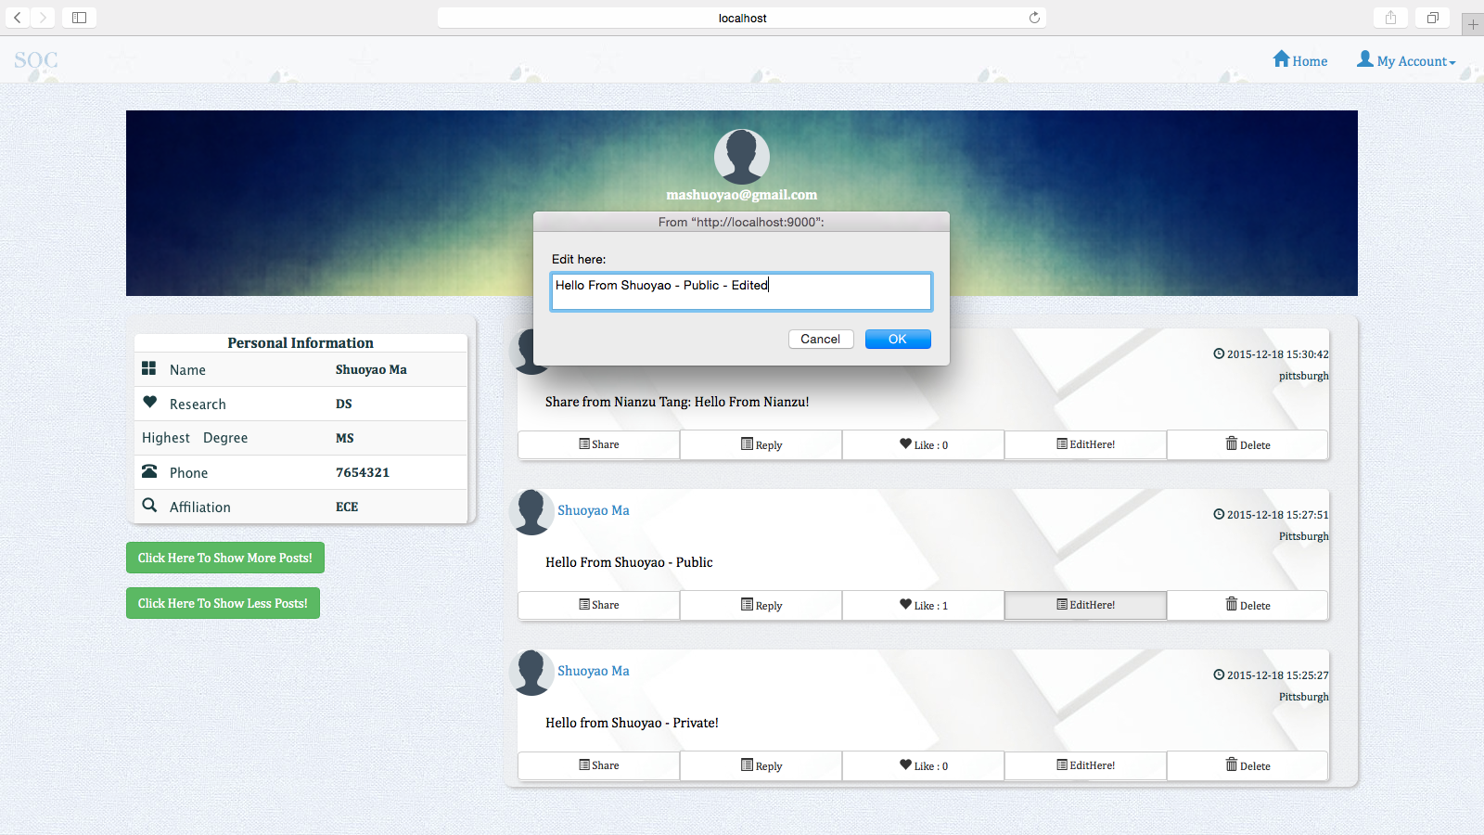

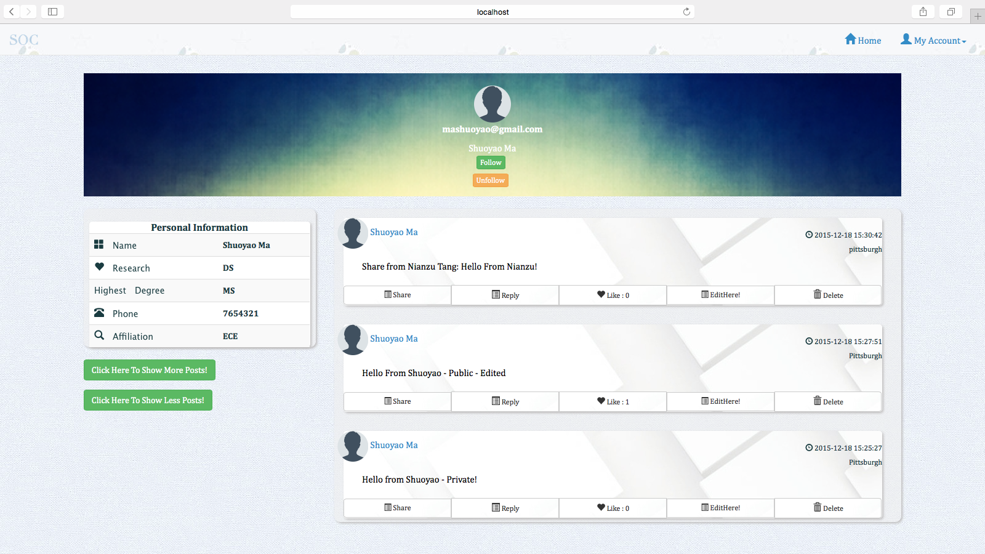

(11) Search Post

User can search post by key word:

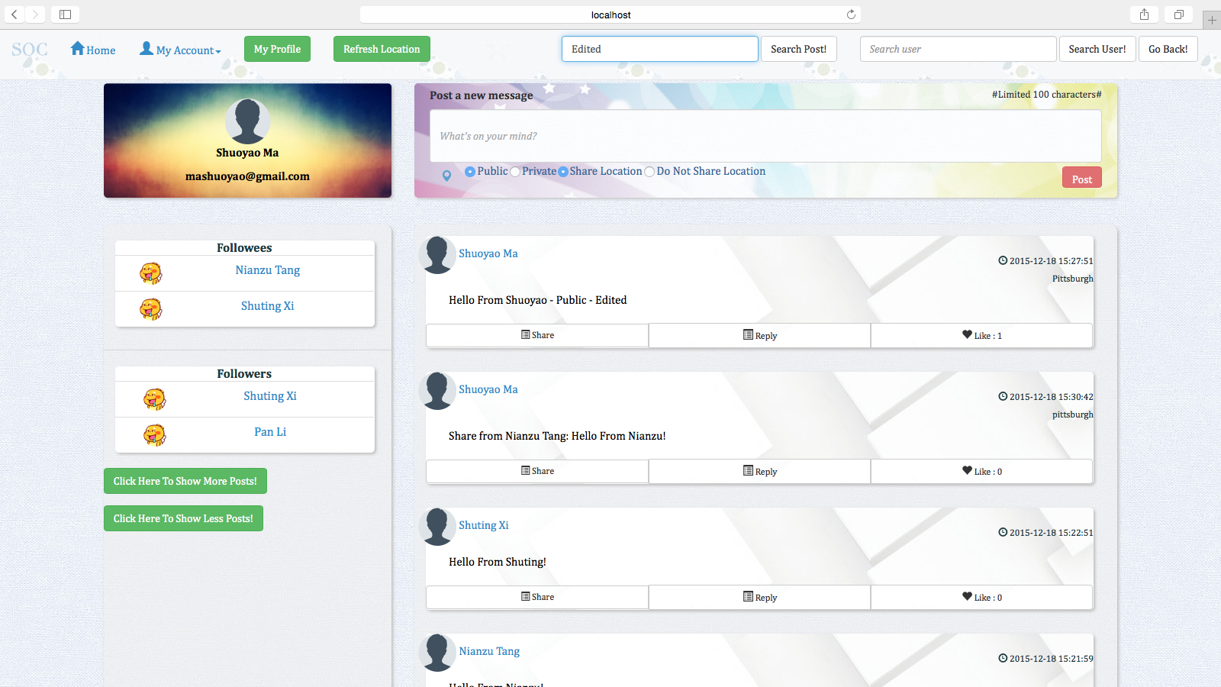

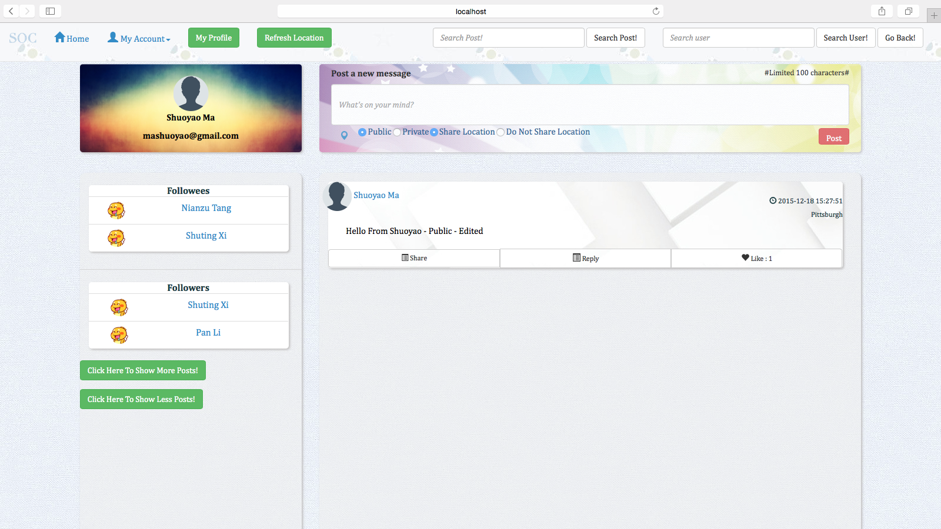

(12) Search User

User can search other users:

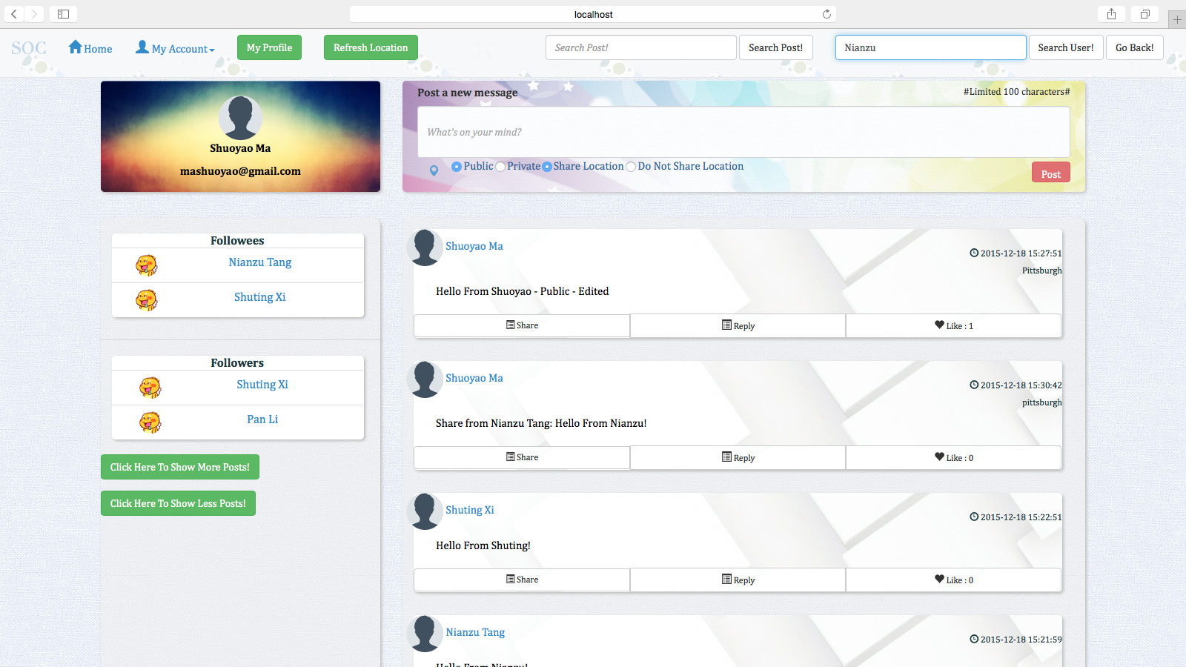

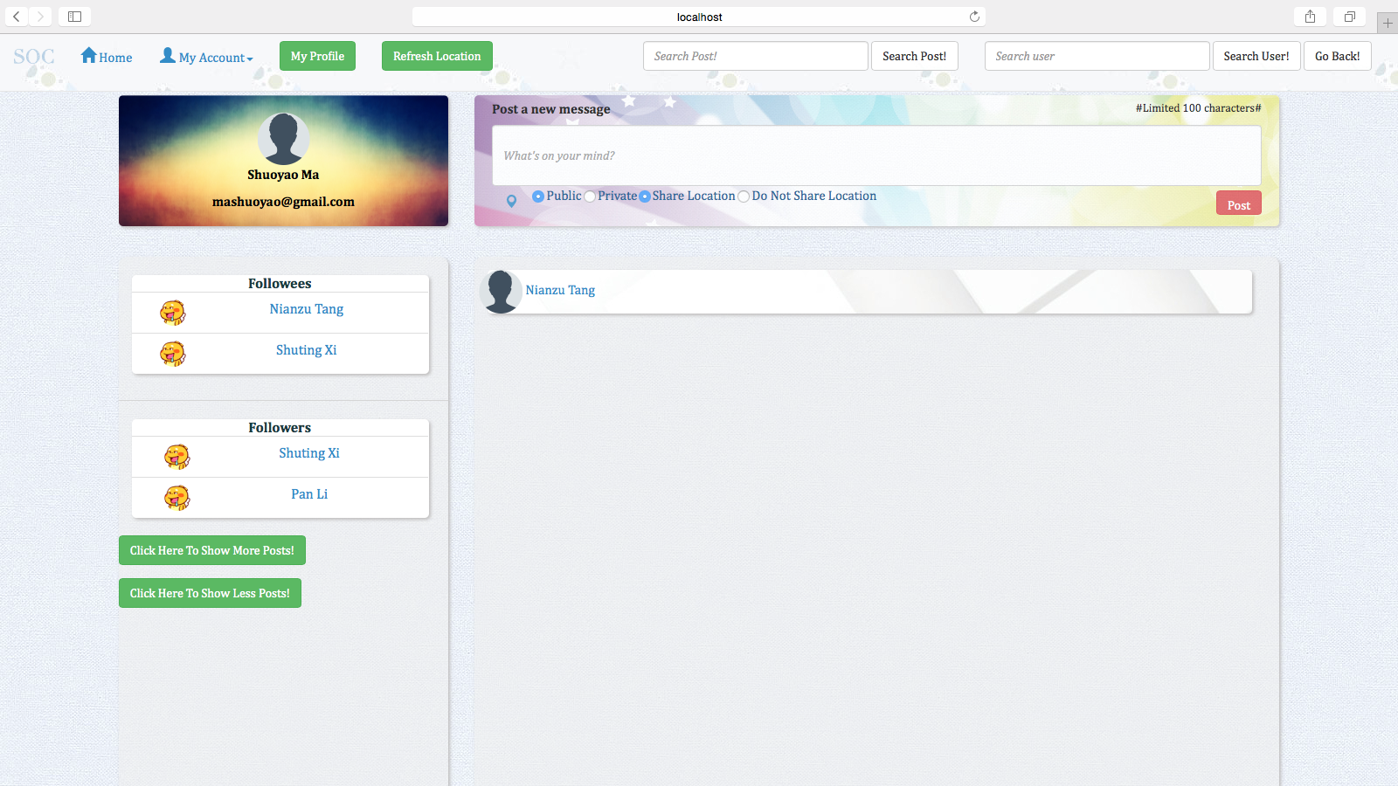

(13) Follow

A user can follow another user by entering the other user, and click follow in his/her home page, after that, the follower and the followee will be reflected in the main page of both users, you can see, Shuoyao has followed Nianzu:

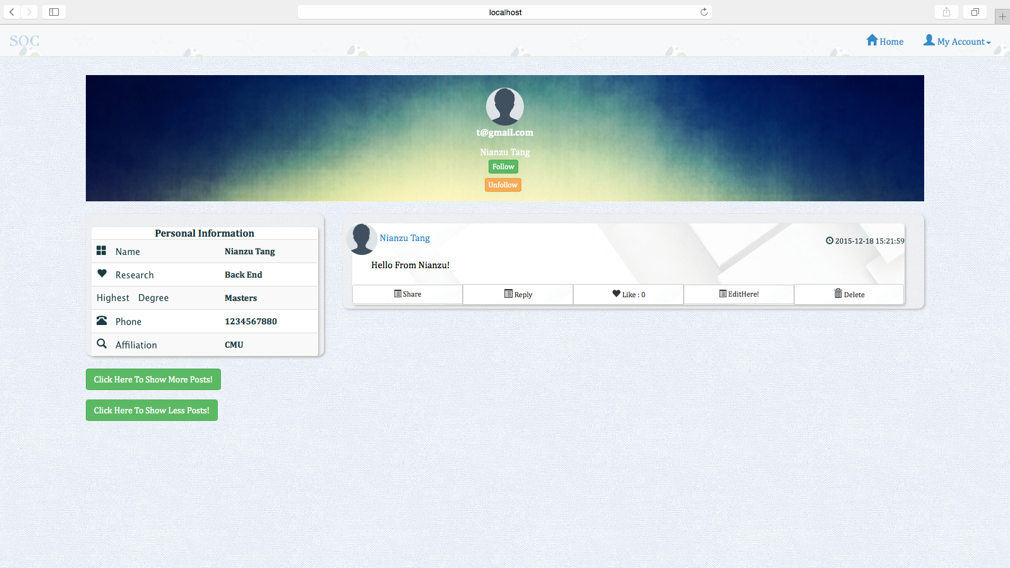

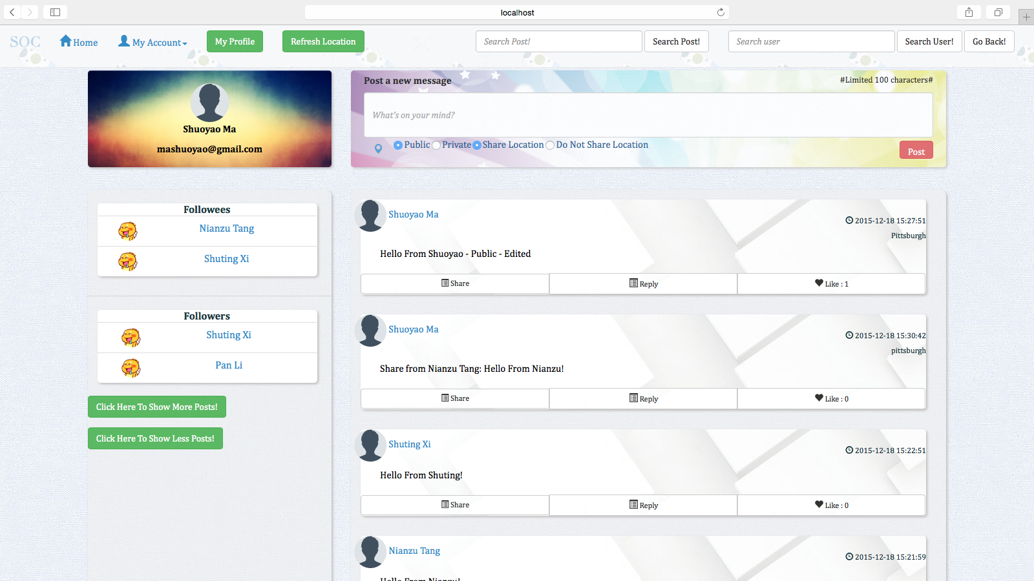

(14) Unfollow

The user can also unfollow another user by entering his/her homepage and click the unfollow button, you can see, Shuoyao has unfollowed Nianzu:

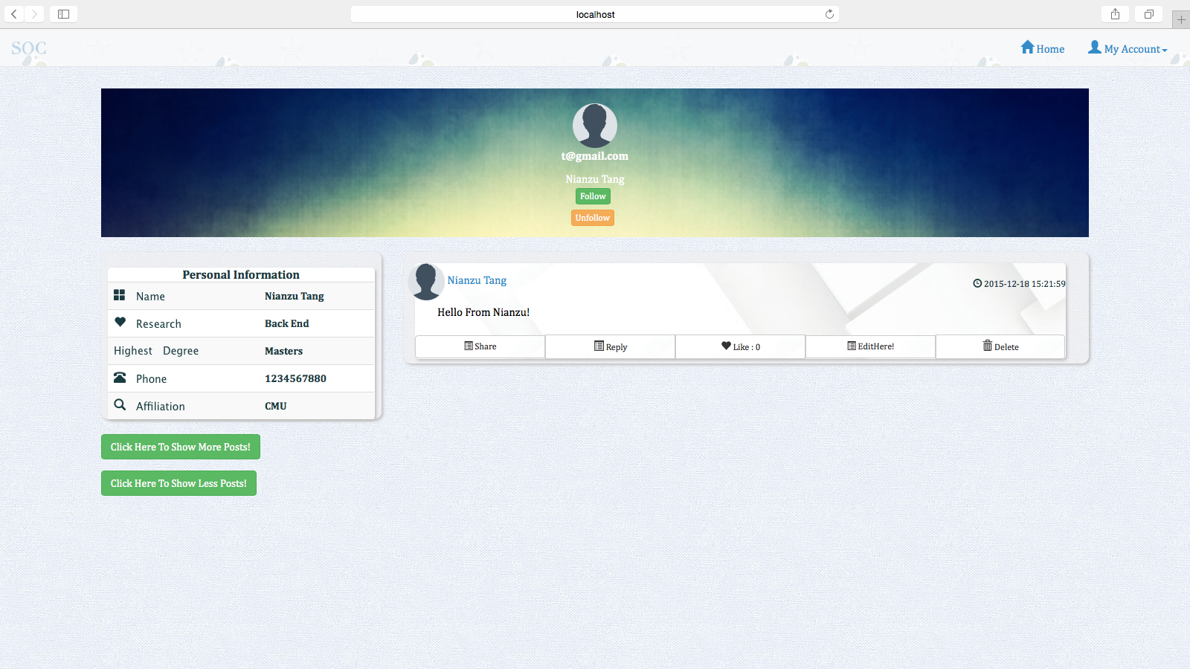

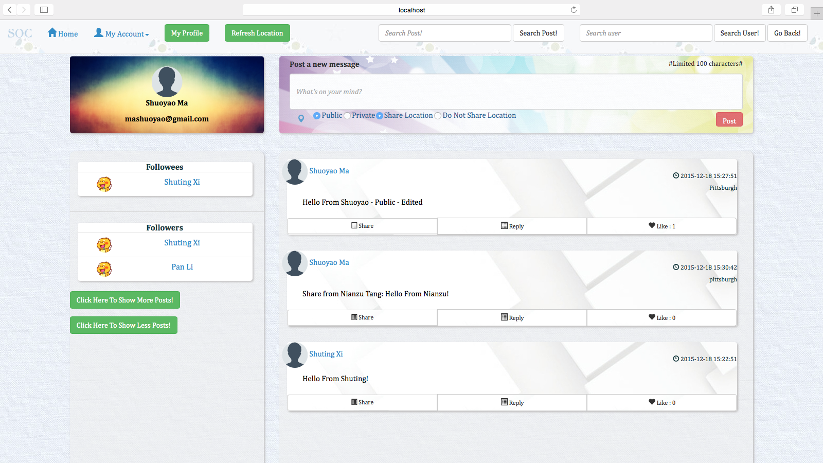

(15) Edit User Profile

The user can edit the profile of himself/herself:

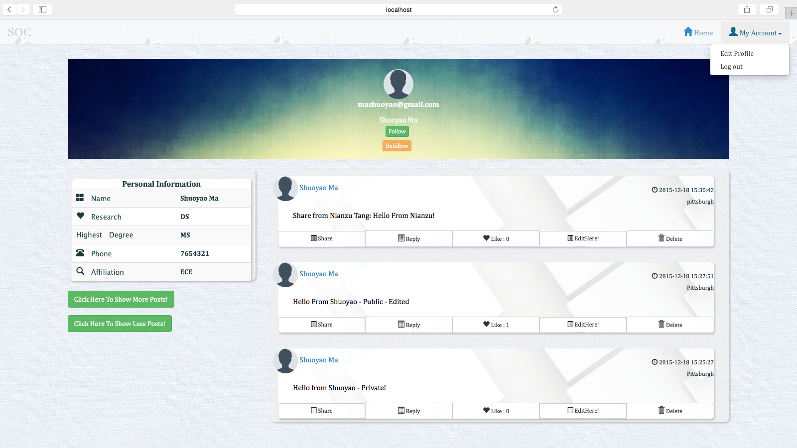

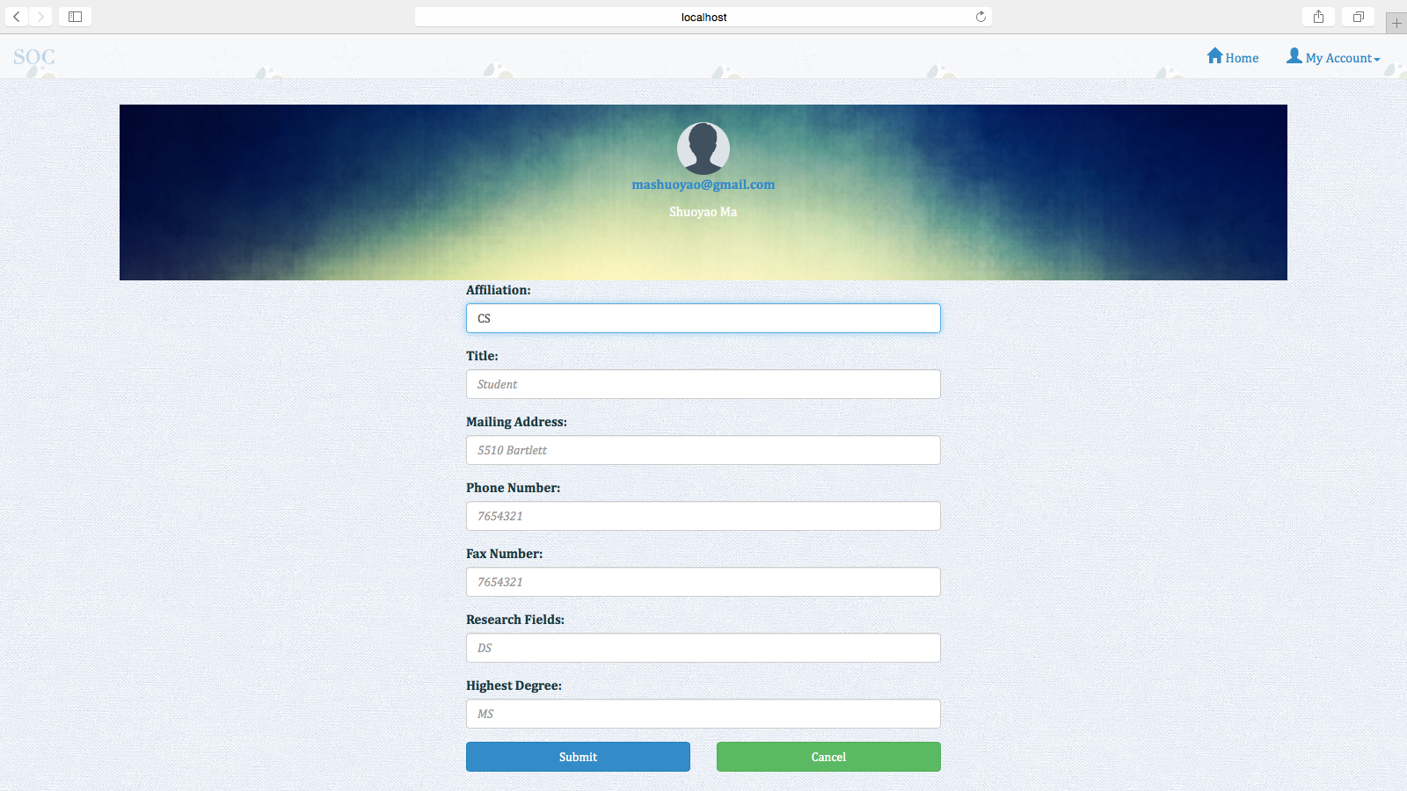

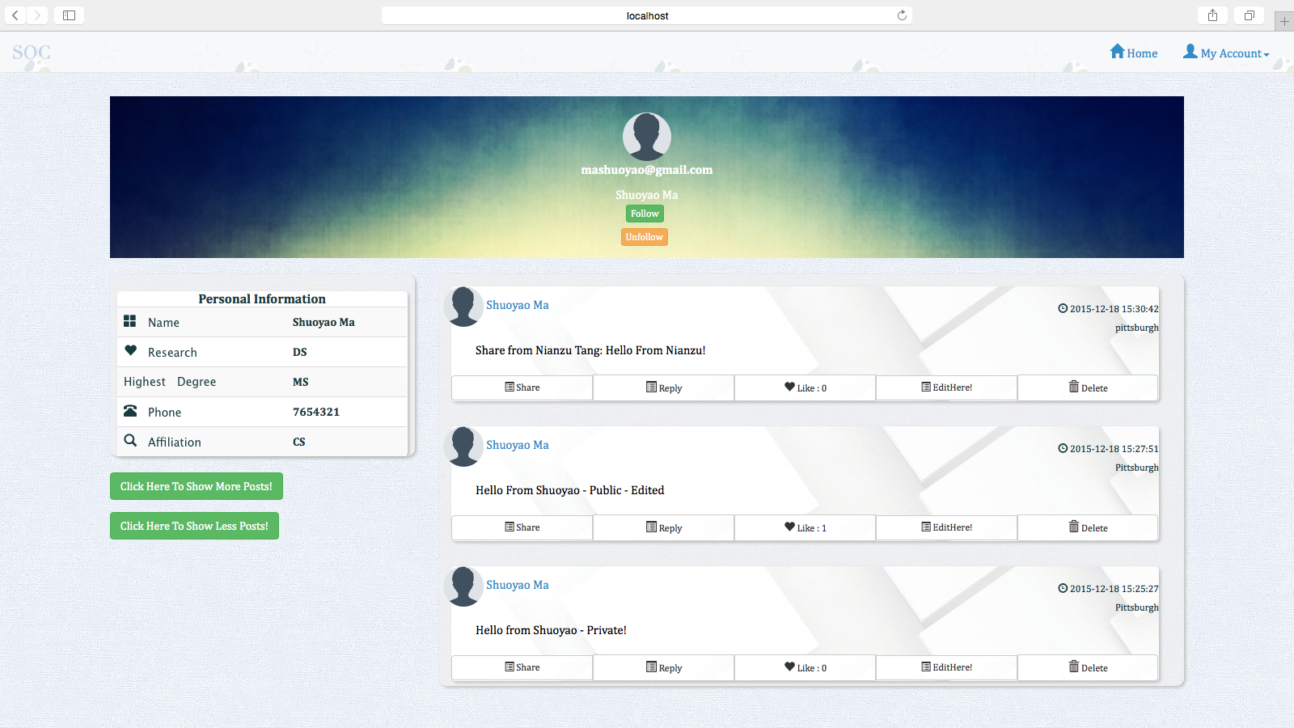

1. **Conclusions and Future Work**
2. **Conclusions**

In this project, we implemented all the required Social Network Features successfully. Besides, we also achieved two more optional features. Our social network, Zetwork, can satisfy the basic needs of people in the contemporary society.

To be more specific, each user can have his/her own homepage and main page. In the homepage, the user can see his/her personal profile, photo and top ten latest posts posted by himself/herself in a time descending order. There is a more button to view all the posts. A user can also view other user’s homepage either by searching the user directly or clicking the user’s homepage link.

Then, in the main page, there are two lists, follower list and followee list. User can view all his/her followers/followees from there. He/She can also see the top ten most popular posts posted either by himself/herself or by his/her followees. There is also a more button to show all the posts.

User can publish posts in main page and he/she can set visibility for posts (If the post is private, it will only be showed on his/her personal homepage. If the post is public, it can be showed both on the personal homepage and personalized main page). Besides, the user can choose whether to share his/her location or not.

Besides, user can do all the basic operations on the posts. First, users can comment on any post that is available to them. They can also like a post or share a post. Then, when user is in his/her own homepage, he/she can delete or edit posts that are published by himself/herself. Other users will not have the access to do so.

What’s more, our social network supports search functions. User can either search keywords of a post or a user. Then the corresponding searching results will appear if they contain the keywords. Thus, our search function is suitable for fuzzy search.

Finally, user can either follow/unfollow another user easily and he/she can edit his/her profile in the main menu.

1. **Future work**

Since Zetwork only supports basic functions of a social network, there are some improvements that can be made to it. Here are some ideas for the future work of Zetwork.

1. Active Log Feature

This feature is used to record the how often the user is logged into the system. The frequency of a user logging into the website social network system in some way shows how the user like the service provided by the website. The user can choose the share his/her active log to other user or not. It could be one of the information listed in the user profile. Similar to the contribution section on "Github" website.

1. Live Chatting Feature

A live chatting feature could be added to our social network system so that users can send instant messages to each other.

1. Third Party Identification

A Third Party Identification feature allows user to be more easily signed into our website, which improved the popularity of our social network .

1. **Contribution of Each Team Member**

In our project development process, we adopted the horizontal arrangement method. Two teammates, Pan Li and Shuoyao Ma, are responsible for front end implementation while other two teammates, Shuting Xi and Nianzu Tang, take charge of back end implementation.

1. **Tutorial**

In this part, we will provide a hand-by-hand tutorial of how to use the Zetwork platform.

1. **Set up**

To set up, please follow the following steps:

a) Download the project from github or other code repository where the code project is.

b) In terminal, cd into the backend project folder and find the folder called “dbDump”. To import the database data into database, please first log into the mysql shell and use the “testdb” database by this command “use testdb;” and then use the command “source databasedump.sql” to import the original data.

c) In terminal, cd into the frontend folder and run the command:

./activator run

d) In terminal, cd into the backend folder and run the command:

./activator "run 9034"

e) The Database connection information is as follows:

user: root

password: set in your own computer as “root”

f) Login URL: localhost:9000/login?

**(2) Sign Up**

To sign up, just click the sign up page and fill in the required information, then you click the submit button, you will get a sign up success page, and your registration has been success.





**(3) Sign In**

After you have signed up, you can use your email address and password to sign in:



**(4) Main Page**

After you have signed in, you will see your main page



**(5) Home Page**

When you click a user name or you click the my profile button, you will see the home page of a user:



**(6) Add Post**

There are many options to add post.

Post added in private will not be seen in the main page, but can be seen in the user’s own home page. In the following screen shots, the post “Hello from Shuoyao - Private” is added, but can be only seen in Shuoyao’s home page when Shuoyao logs in.







Post Added in public will be seen by others in the main page. The Post “Hello World” Posted by Shuoyao has been seen in the main page and also in the home page.







There is also an option that you can choose to add post but do not share your location, the post without the location is posted when the user chose the “Do Not Share Location” option when posting:



**(7) Delete Post**

The user can delete his/her post in his/her own home page, you can see, the post “Hello World” Has been deleted:



**(8) Like Post**

A user can like a post, you can see, the post “Hello From Shuoyao - Public” has been liked, it has 1 like:



**(9) Comment Post**

A user can comment the post of other users, you can see, Shuoyao has commented Shuting’s Post:





**(10) Share Post**

A user can share the post of another user, you can see, Shuoyao has shared the post of Nianzu:



**(11) Edit Post**

A user can edit post in his/her own home page:





**(12) Search Post**

User can search post by key word:





**(13) Search User**

User can search other users:





**(14) Follow**

A user can follow another user by entering the other user, and click follow in his/her home page, after that, the follower and the followee will be reflected in the main page of both users, you can see, Shuoyao has followed Nianzu:





**(15) Unfollow**

The user can also unfollow another user by entering his/her homepage and click the unfollow button, you can see, Shuoyao has unfollowed Nianzu:





**(16) Edit User Profile**

The user can edit the profile of himself/herself:







**Appendix:**

-Check in everything onto GitHub under the predefined directory including the following items

-Readme file: Describe briefly the purpose of the project, how to download and install the software, how to use the software

*Please refer in the “README.md” file in the github reporsitory*

-API (sub-directory): instruct APIs as well as descriptions and examples

*Please refer in the “1.API.docx” file* *in the document folder*

-Test Suite (sub-directory): a collection of test examples and descriptions

*Please refer in the “2.TestSuite.docx” file in the document folder*

-src (sub-directory): include all source code categorized by packages

*Please refer in the code folder “*ApacheCMDA-Backend*” and “*ApacheCMDA-Frontend*”*

-lib (sub-directory): include all related library packages needed to support the project

*Please refer in the code folder “*ApacheCMDA-Backend*” and “*ApacheCMDA-Frontend*”*

-conf (sub-directory): include any confirmation settings and files

*Please refer in the code folder “*ApacheCMDA-Backend*” and “*ApacheCMDA-Frontend*”*

-app (sub-directory): any applications built on top of the APIs

*Please refer in the code folder* *“*ApacheCMDA-Backend*” and “*ApacheCMDA-Frontend*”*

-contact: please provide every team member’s contact information (cell number, personal email)

*Please refer in the “3.Contact.docx**” file in the document folder*

-Check in everything onto DockerHub under the predefined directory

-Documents (sub-directory): in different WORD files

-access information: URL, user name/password

*Please refer in the “4.Access information Username and Password” file in the document folder*

-download and installation documents with step-wise descriptions

*Please refer in the “5.Download and Running instruction” file in the document folder*

-executive summary

*Please refer in the “6.Executive Summary” file in the document folder*

-background and motivation

*Please refer in the “7.Background and Motivation” file in the document folder*

-assumptions and considerations

*Please refer in the “8.Assumptions and Considerations” file in the document folder*

-design documents (architectural design documents and various diagrams e.g., UML files)

*Please refer in the “9.Design Documents” file in the document folder*

-discussions

*Please refer in the “10.Discussion” file in the document folder*

-presentations (ppt file)

*Please refer in the “11.ZetWork_SOC Project Final Presentation” file in the document folder*

-tutorial: step-by-step usage file with screen shots included

*Please refer in the “12.Tutorial” file in the document folder*

-future work: to-do list and descriptions

*Please refer in the “13.Future Work and ToDo List” file in the document folder*

-technical report

*Please refer in the this file in the document folder*

-Transit the knowledge to either Advisor or a signed student (schedule time to sit down for transition)